SAP Build Apps – Demo Scripts
For exercises from Learning Journey Utilize SAP Build for Low-Code/No-Code Applications and Automations for Citizen Developers .

Pre-requisites

Pre-requisites set-up tutorial https://developers.sap.com/tutorials/appgyver-subscribe-service.html
Descriptin | Screenshot
enterprise account (optional, use community edition instead) | https://developers.sap.com/tutorials/appgyver-subscribe-service.html  The community edition is available here: AppGyver.com
booster (optional, use community edition instead) | https://developers.sap.com/tutorials/appgyver-subscribe-service.html  The community edition is available here: AppGyver.com
preview app (optional, use the preview link and open it in mobile browser instead) | https://help.sap.com/docs/build-apps/service-guide/mobile-app-preview  Android phone scans here iPhone scans here  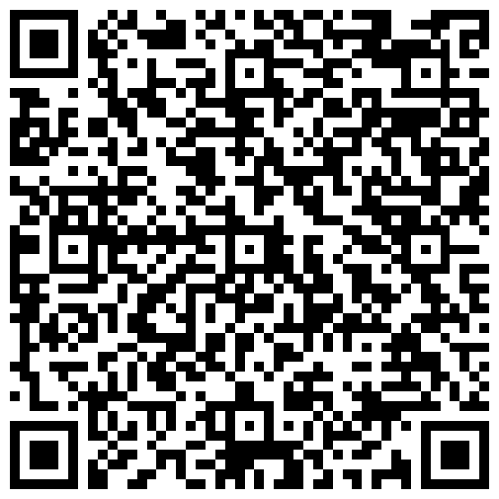 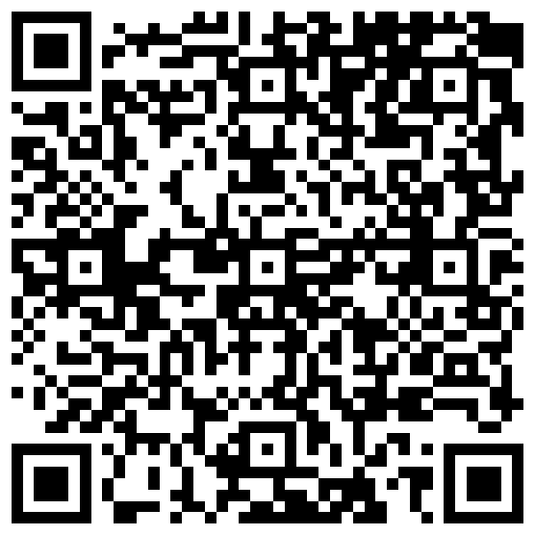

Food Barcode Scanner - Scan Barcode to Text
Descriptin | Screenshot
Set up project and preview
Start a new project | 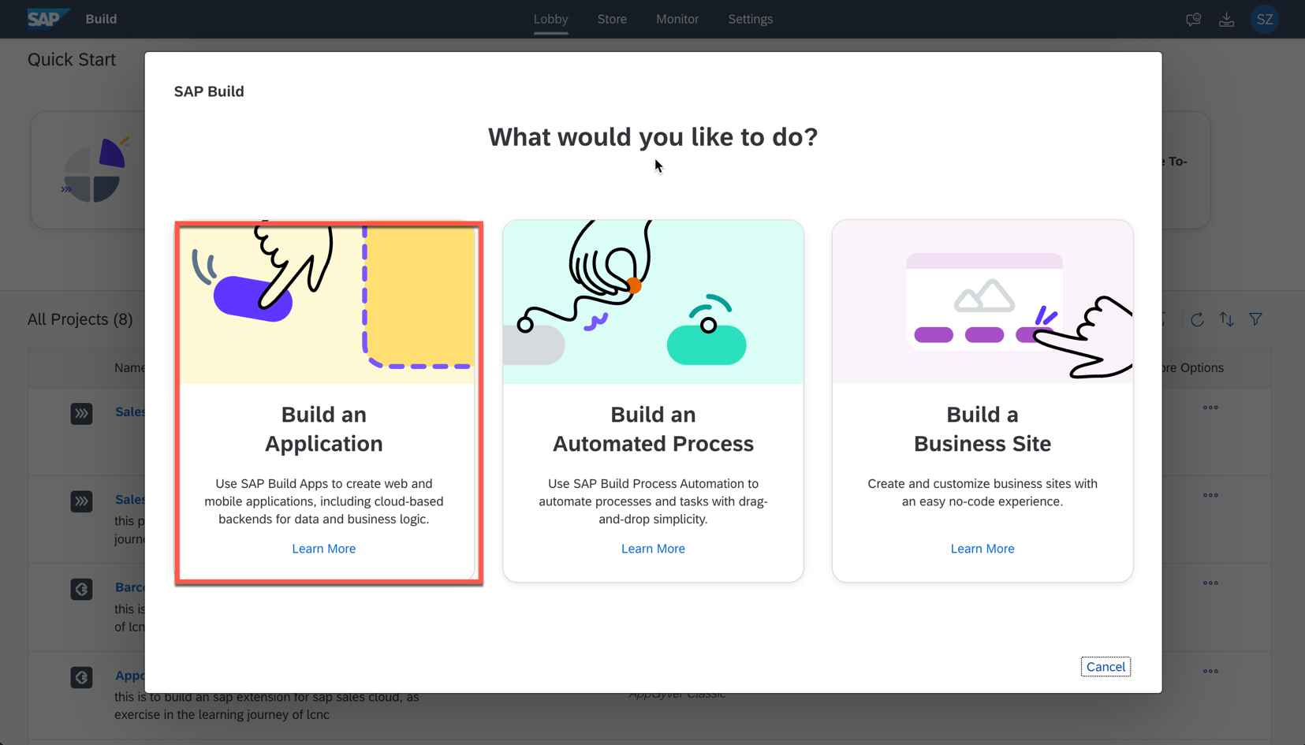
Click the link to use AppGyver Community edition,  Give it name  Name Barcode Scanner App  Click create | 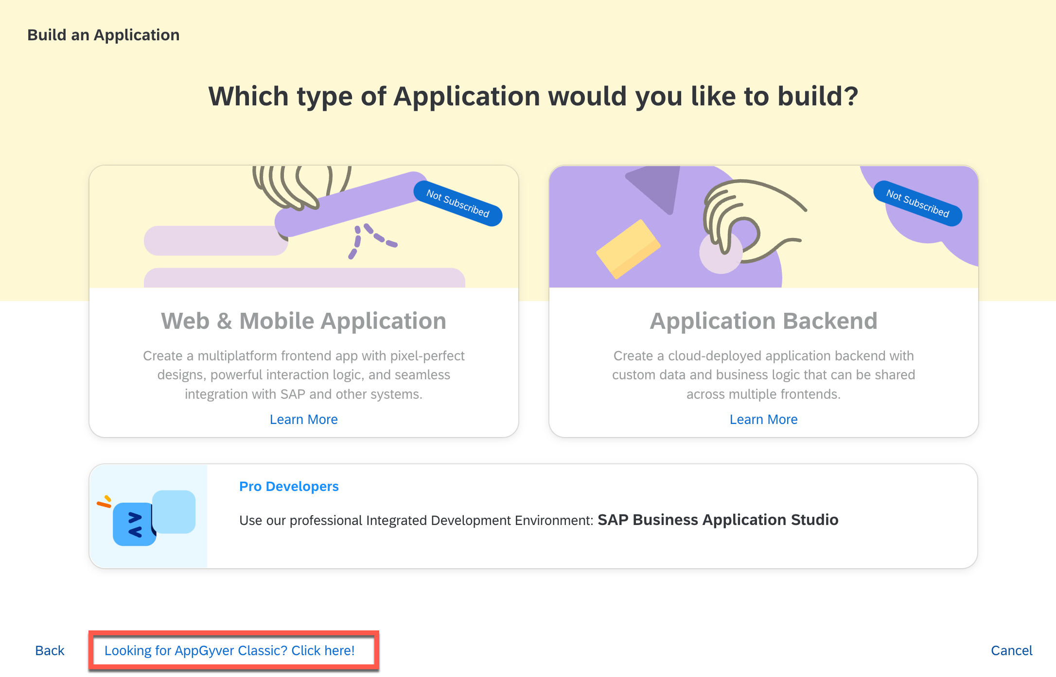
Get to know the interface,  check device iphone (default is what we want so no need to change it) | 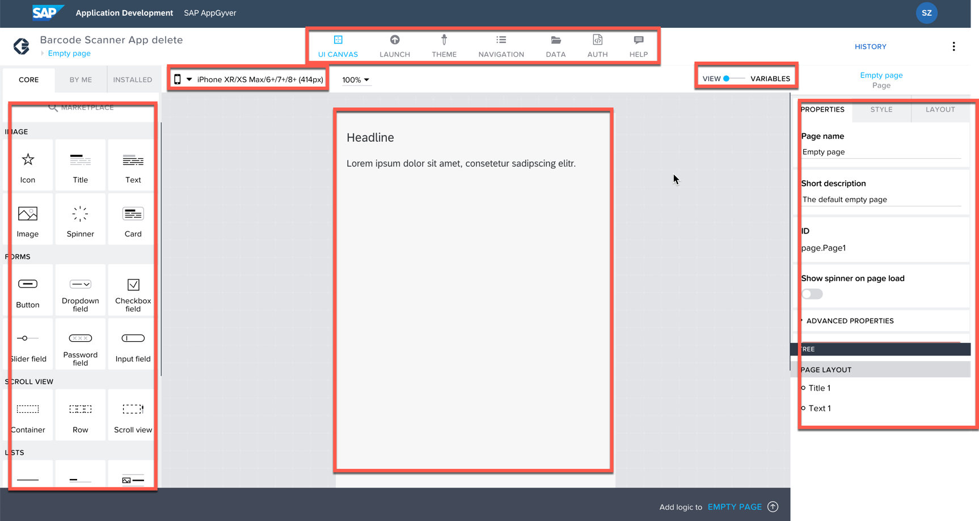
Preview the project on your phone:  Open Launch tab, select "open preview portal" | 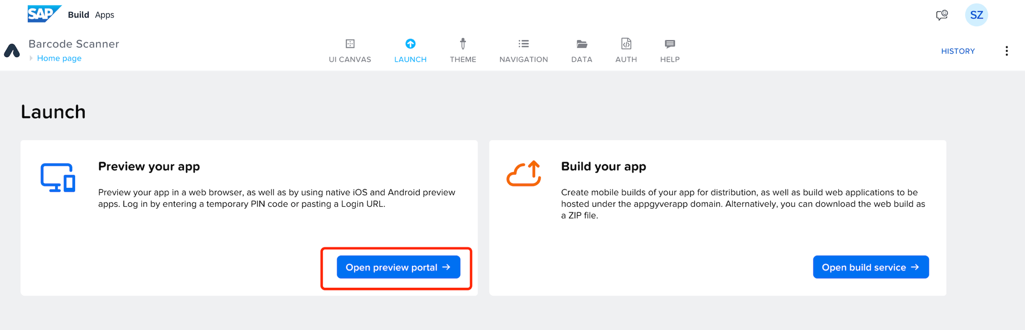
In Preview app on your mobile phone, click "SAP Buil Apps" to generate code.  If your SAP Build Apps tenant is on other region, click "Other login options" and select your edition (e.g. for trial account, select " SAP Build Apps US10"). | 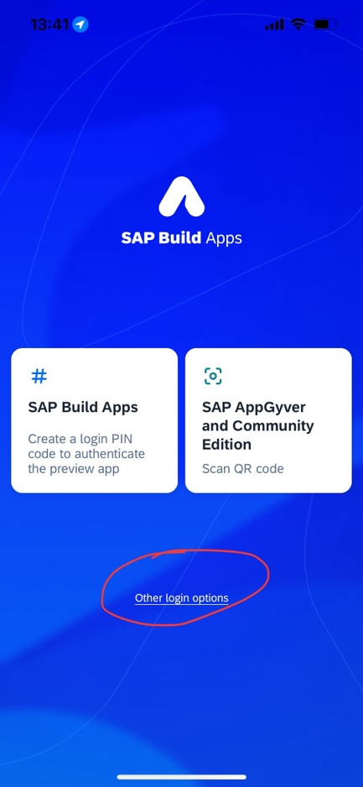à 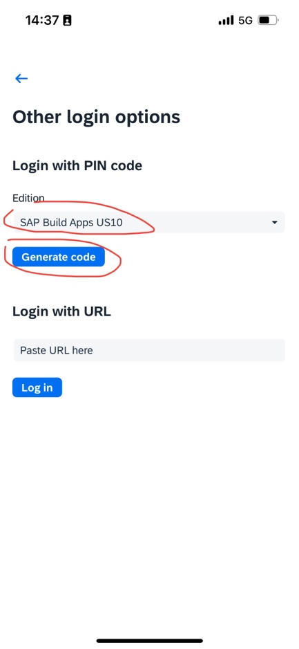à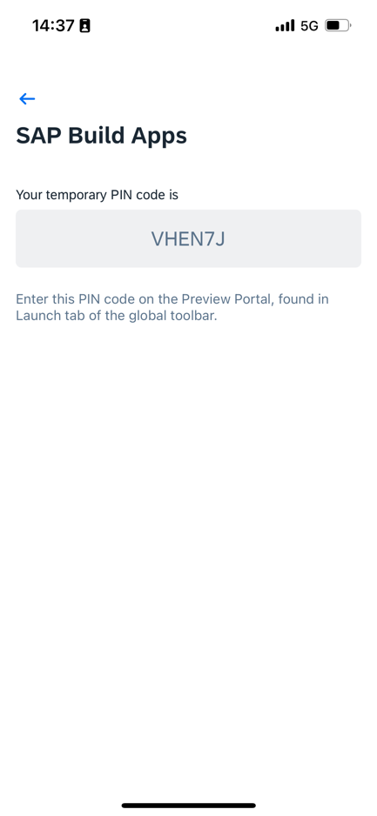
Go to launch page in your browser, paste PIN code and click "Confirm pin", your preview is set on your device. | 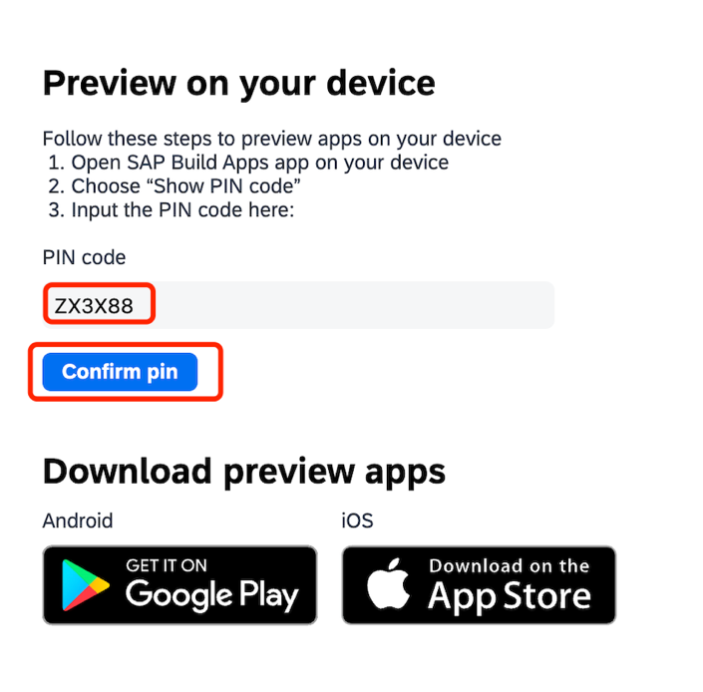à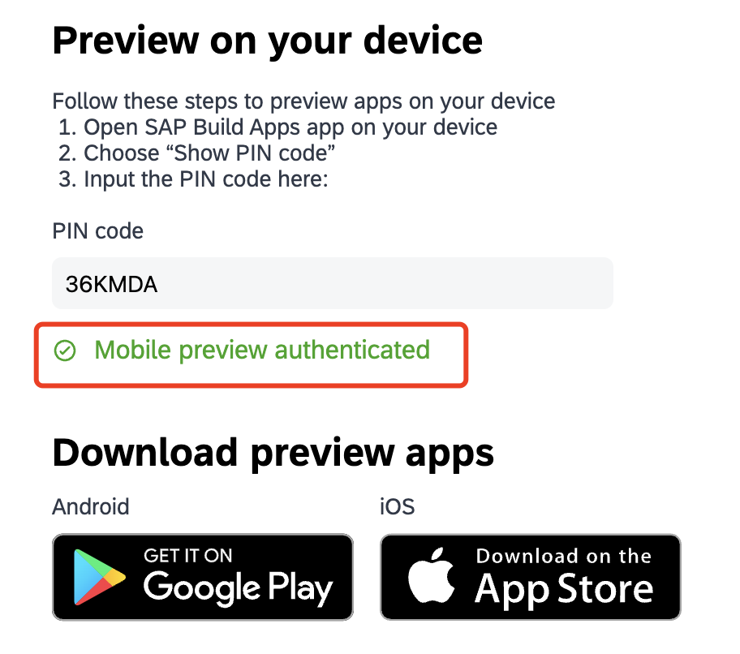à 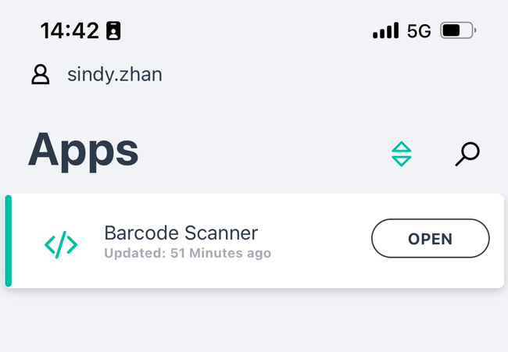
create UI
Delete the default components | 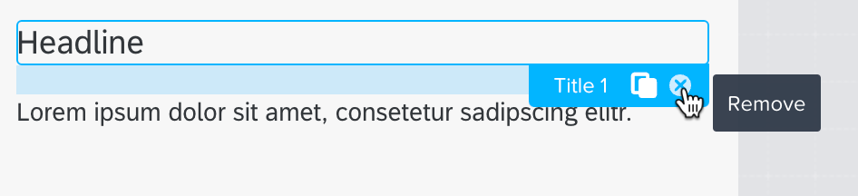
Drag a button, name it “Scan Barcode” | 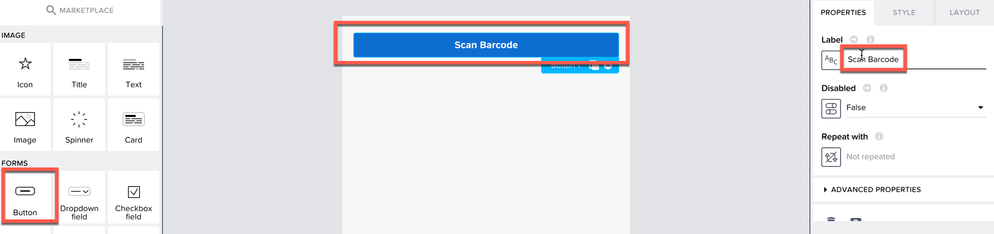
Drage two “Text” before the button:  first line to show product name, second line to show product calories | 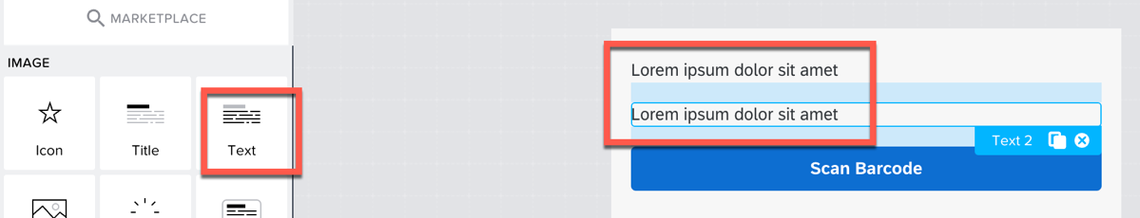
Business rules in logic flow
Select the button,  Unfold logic canvas,  drag and drop “Device | Scan QR/barcode”,  connect it to “Event | Component tap”, | 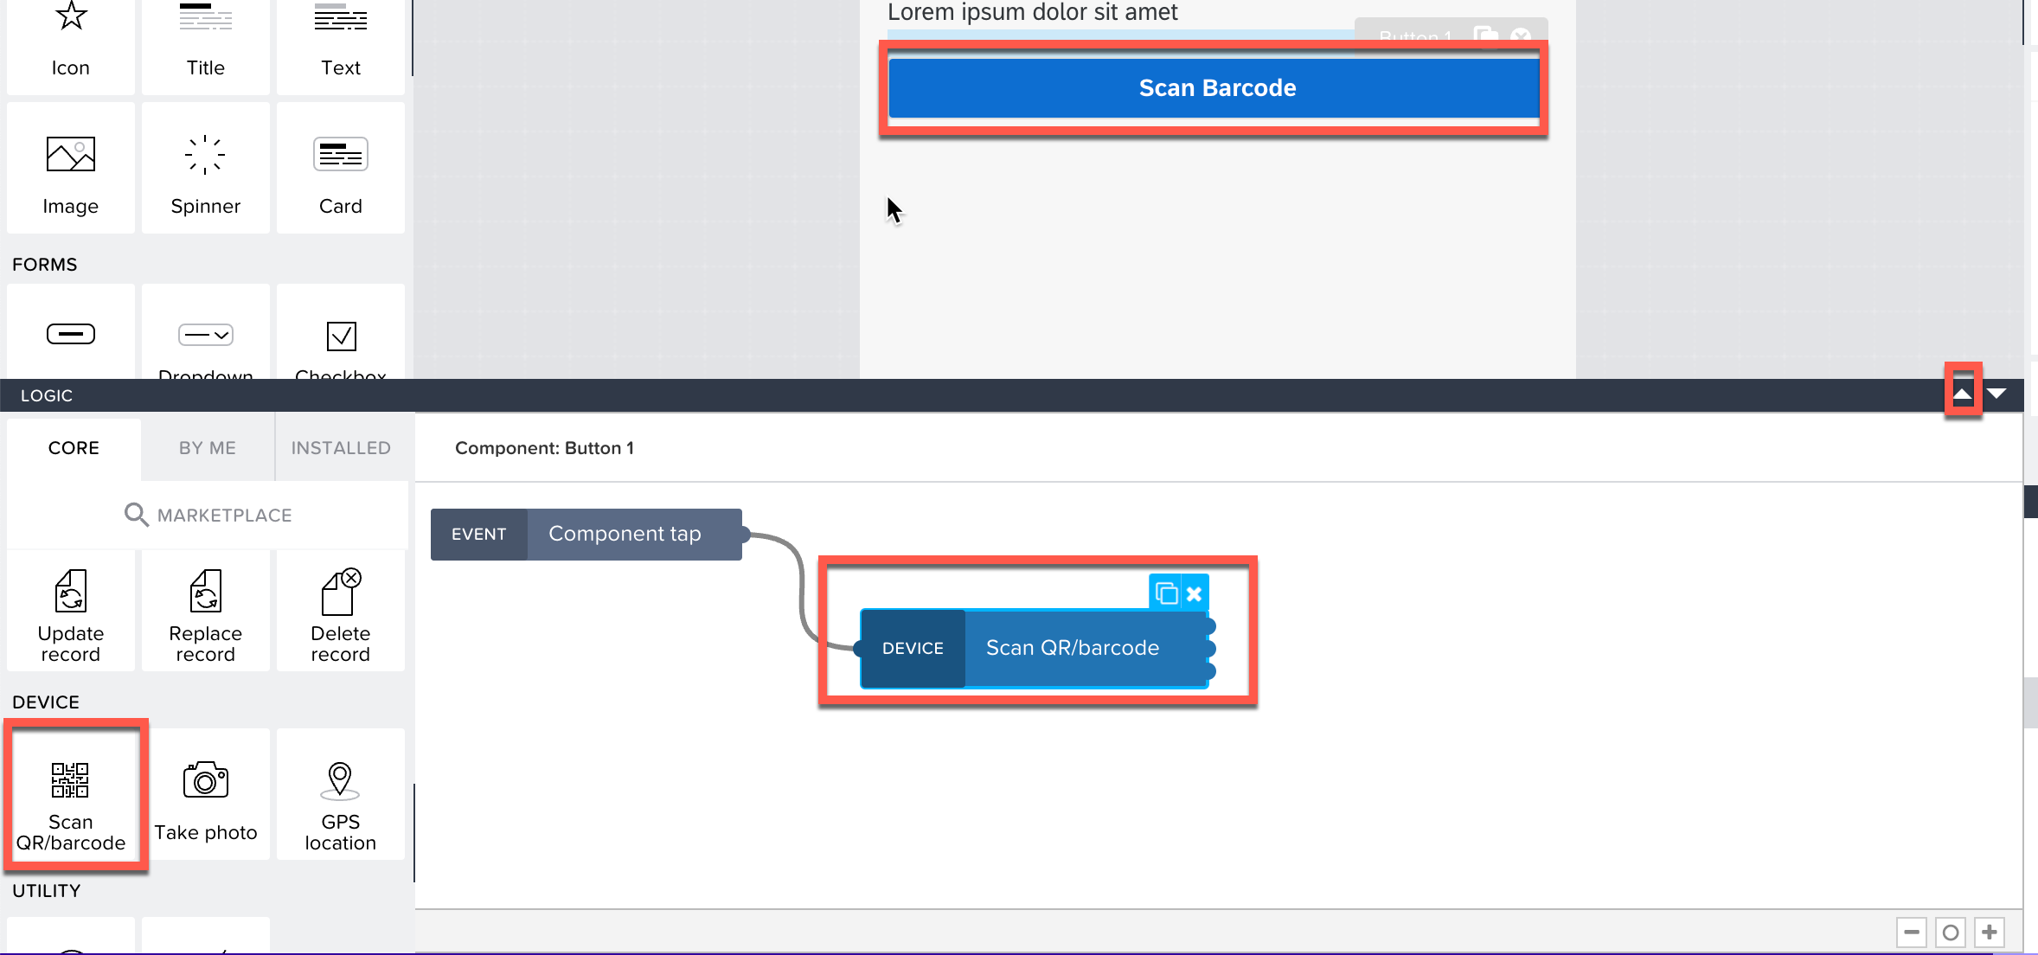
drag and drop “Dialog | Alert”,  connect it to “Device | Scan QR/barcode”, (remember to choose the first output port) | 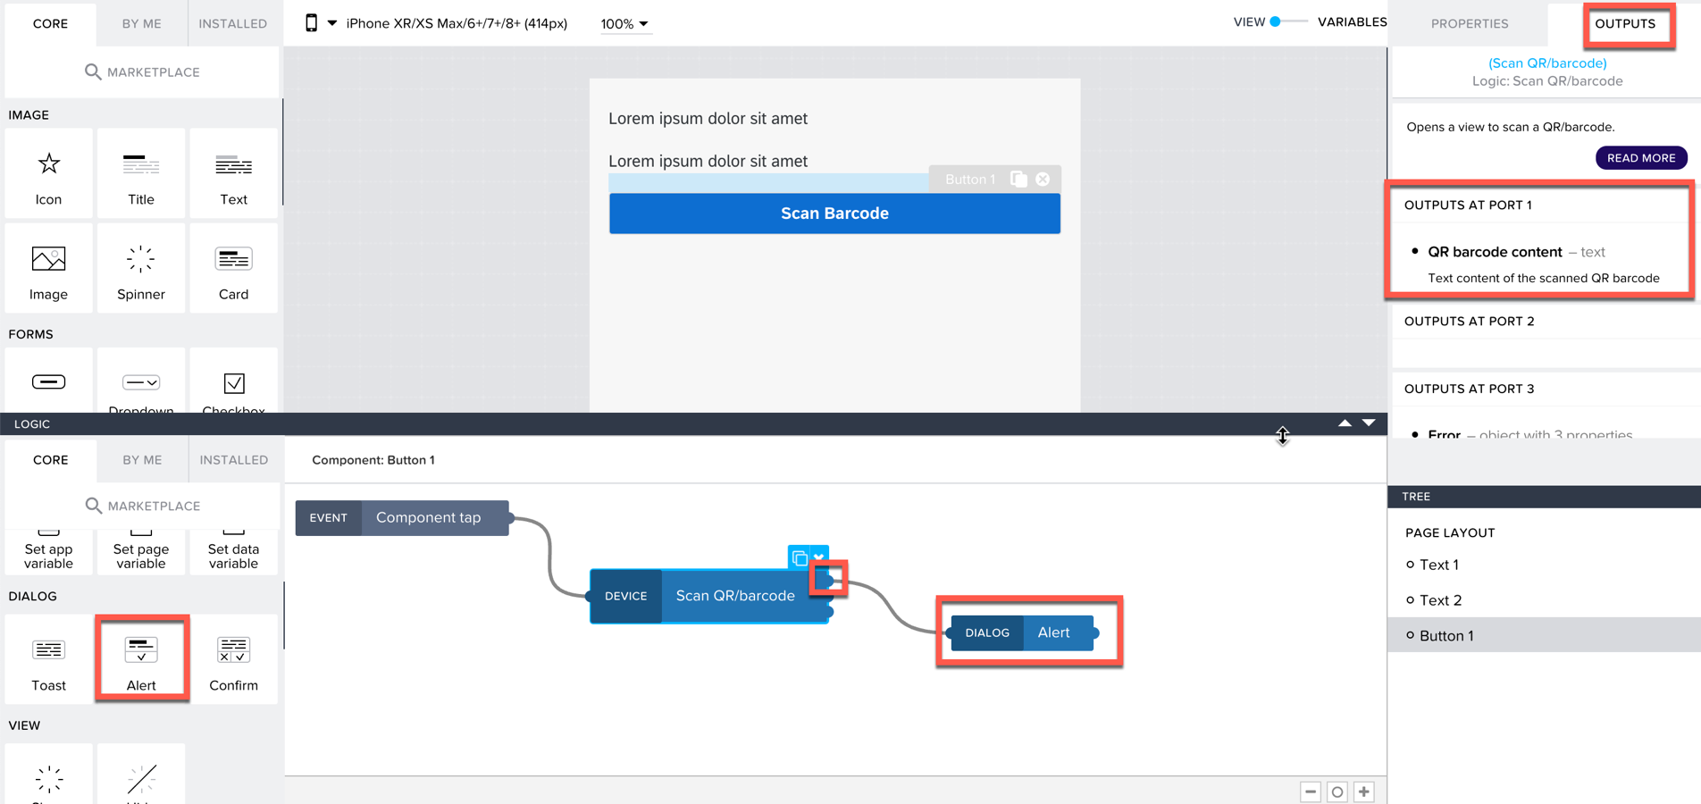
Variable and component binding:
Select “Dialog|Alert”,  Bind variable to Dialog title | 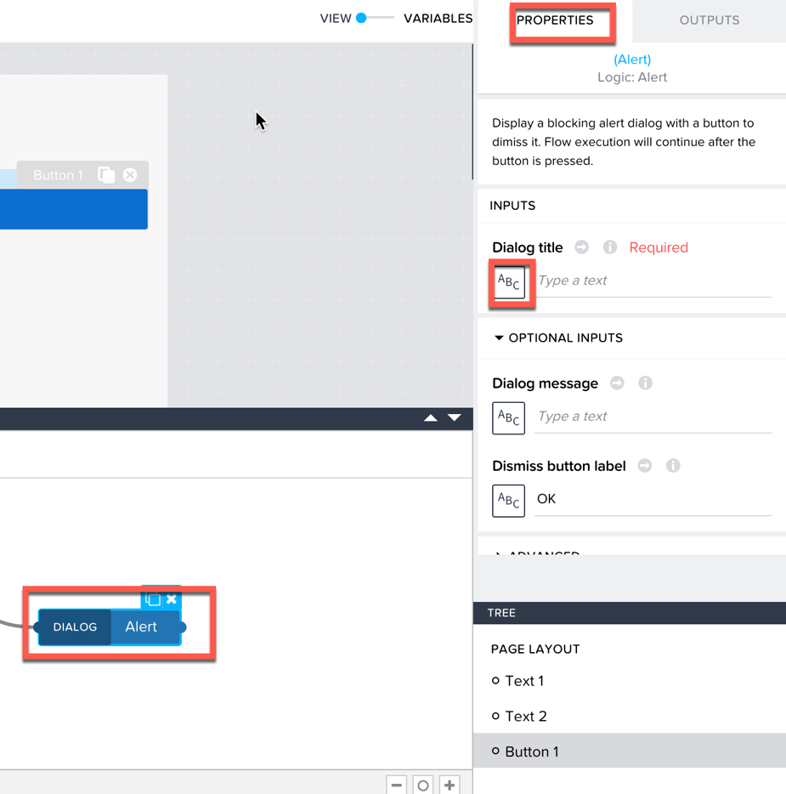
In the wizard, select “Output value of another node” > “Scan QR/barcode” > “QR barcode content” | 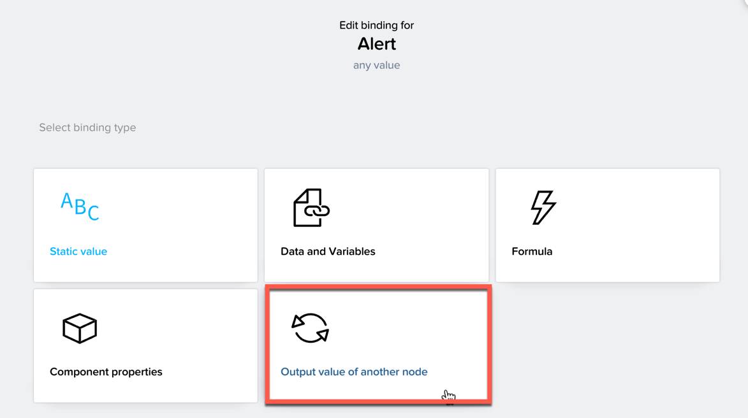  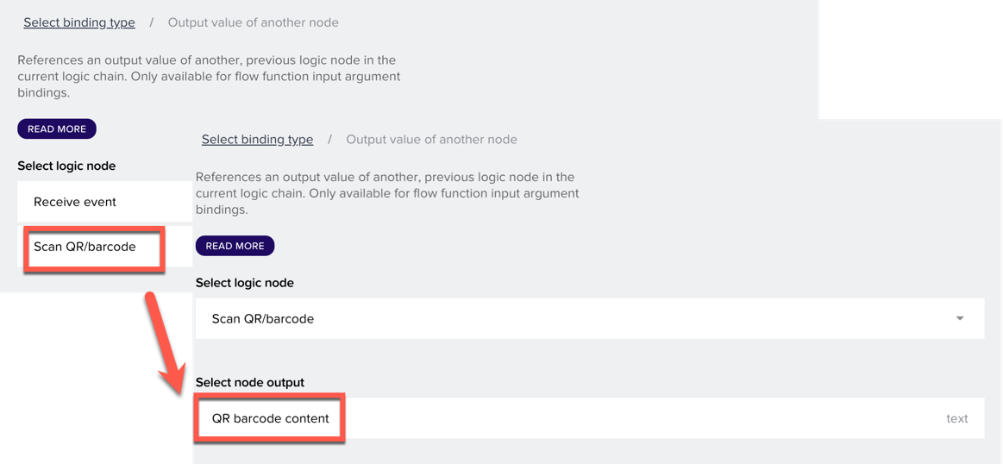
Save it and test it on the phone | 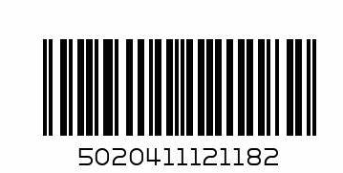  Pop out: 5020411121182
Test results | 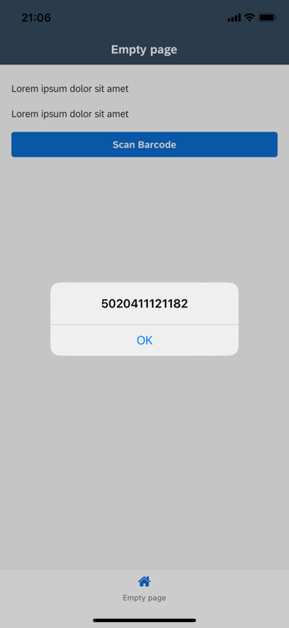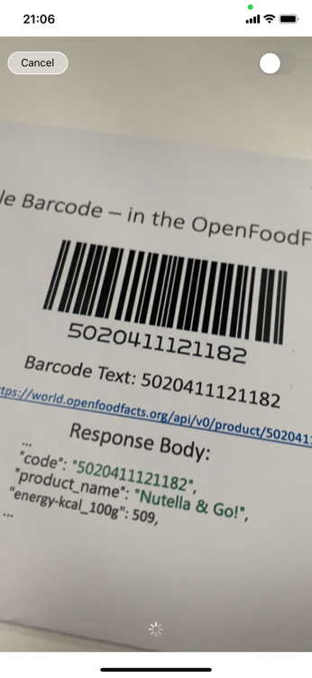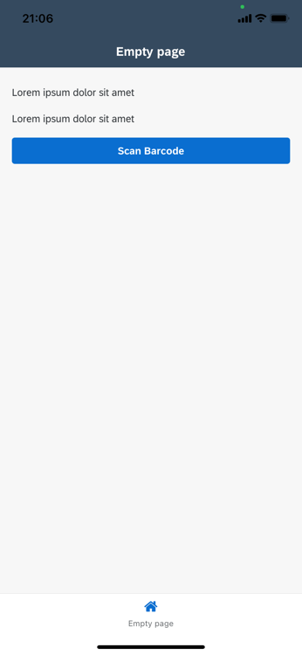

Food Barcode Scanner – Call API
Descriptin | Screenshot
Check API
Open https://world.openfoodfacts.org/  Scroll to the footer and open "Data, API and SDKs", | 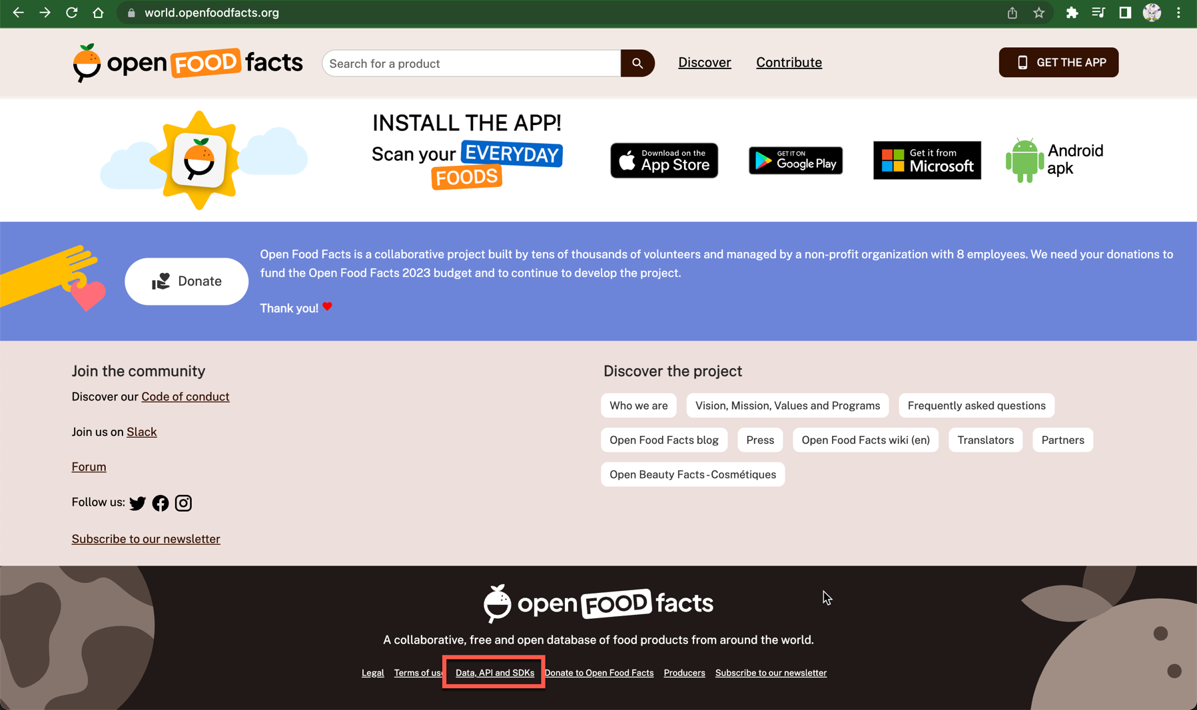
notice the URL to read data for a product here, we will make use of it in our app: https://world.openfoodfacts.org/api/v0/product/{barcode}.json | 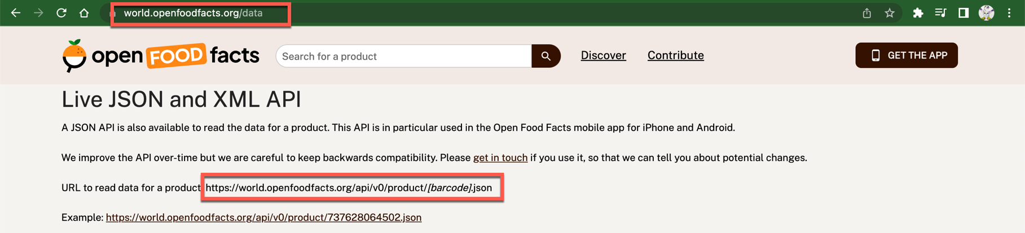
add it as data source
"data" tab > "Create data entity" > "REST API integration" | 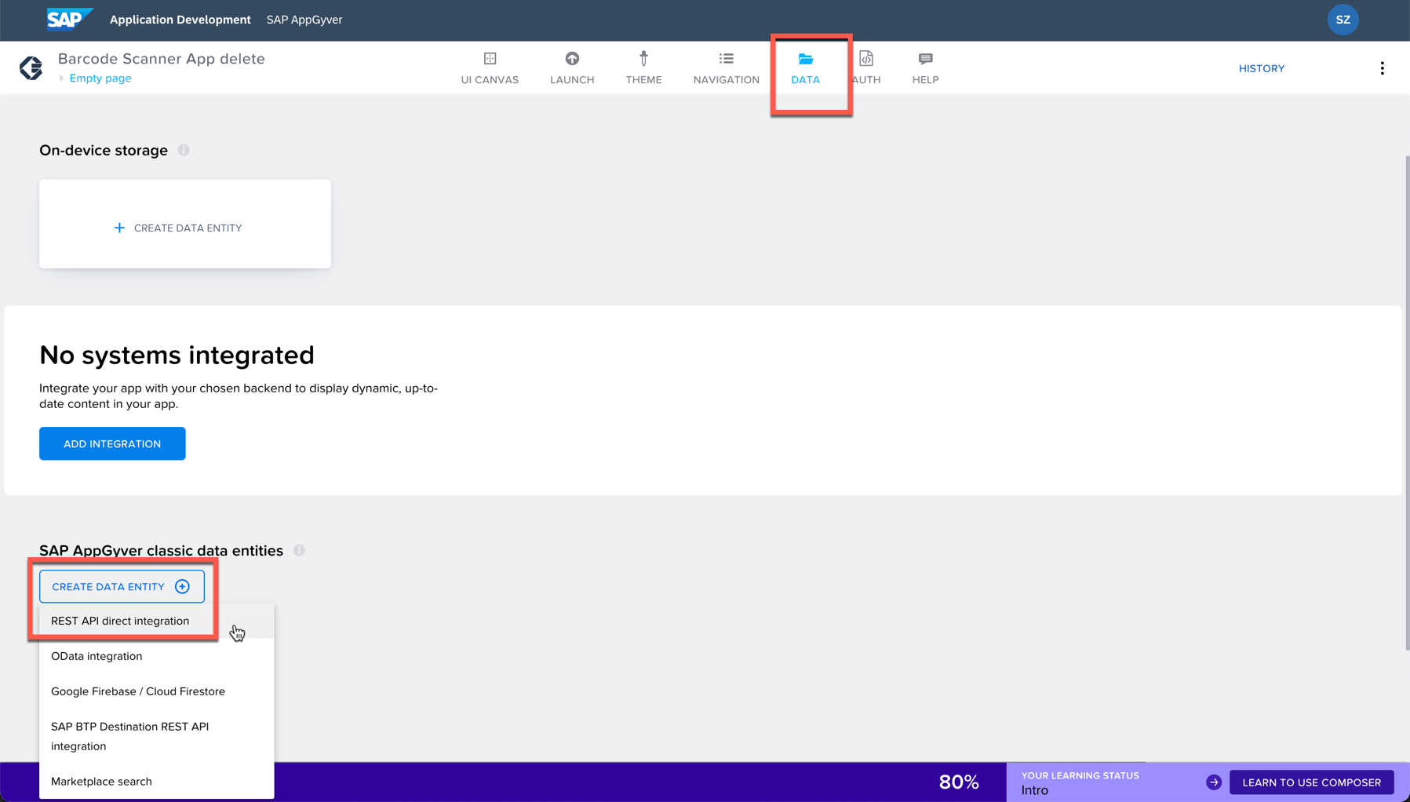
fil in info  resource ID openfoodfacts  short description data from openfoodfacts api  resource URL https://world.openfoodfacts.org/api/v0 | 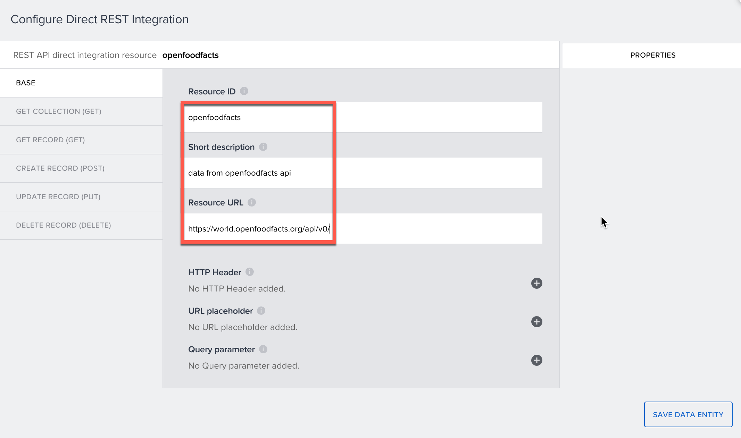
select method "Get Record (GET)",  fill in the path: /product/{barcode}.json  set parameter as url placeholder: {barcode} | 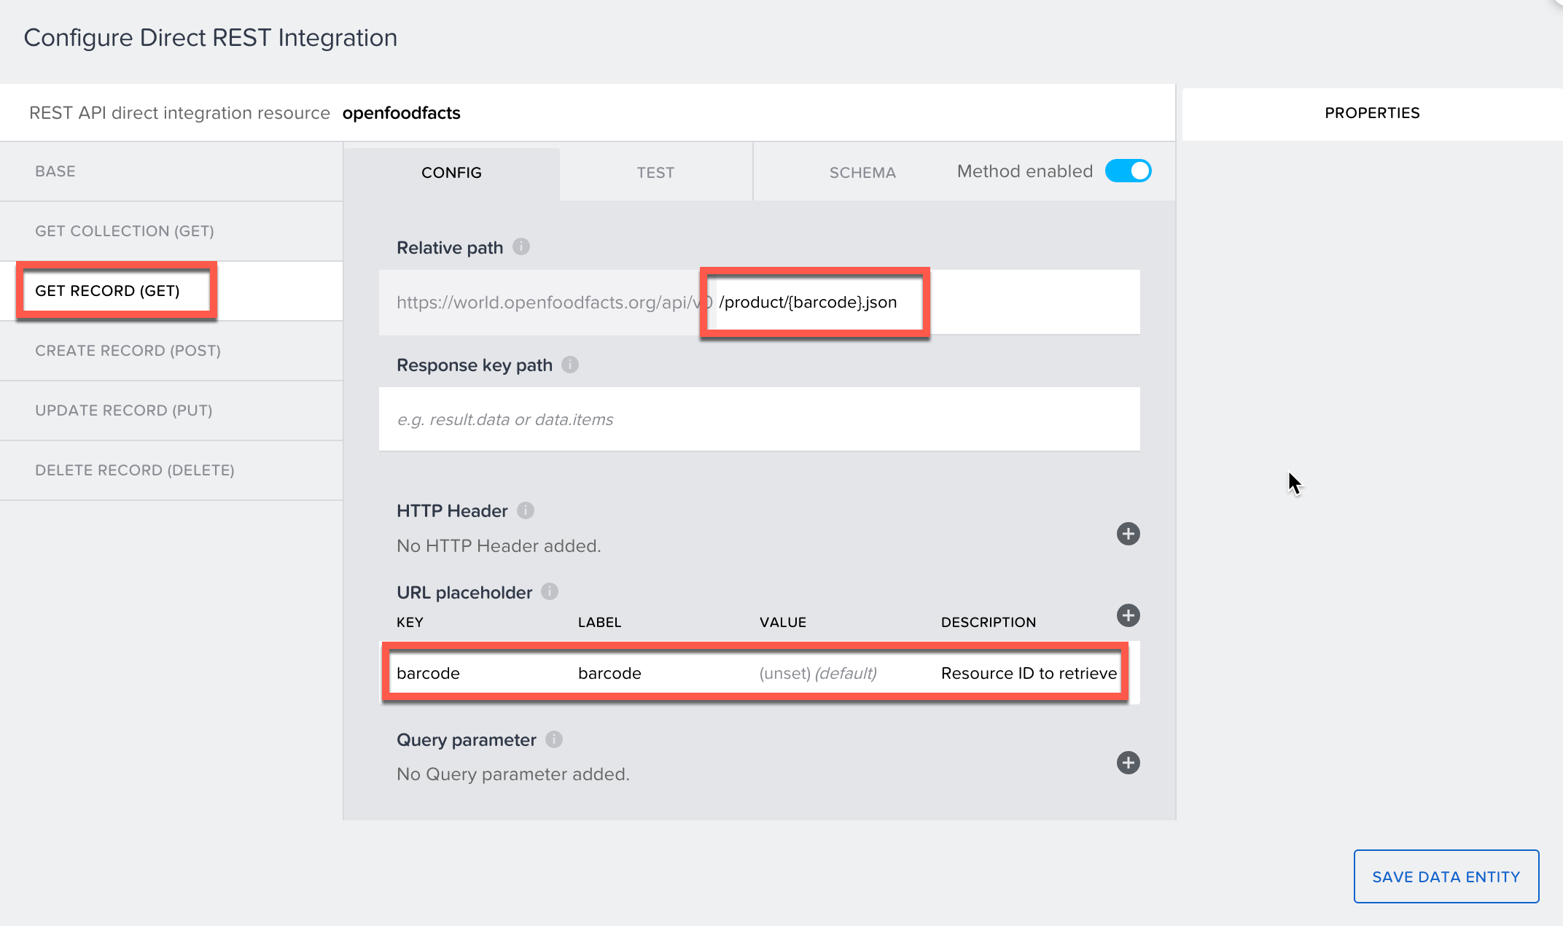
Go to "Test" tab, enter the barcode test value "5020411121182", click "Run Test".  Check the response status and body, find the field we want (ctrl+f to find by key word):  - product_name  - energy-kcal_100g | 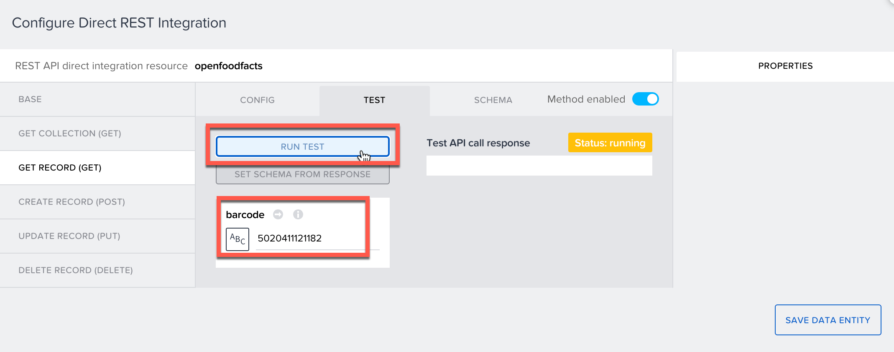
Click "set schema from response", and the go to "Schema" tab,  check:  - product.product_name  - product.nutriments["energy-kcal_100g"]  Click "Save Data Entity". | 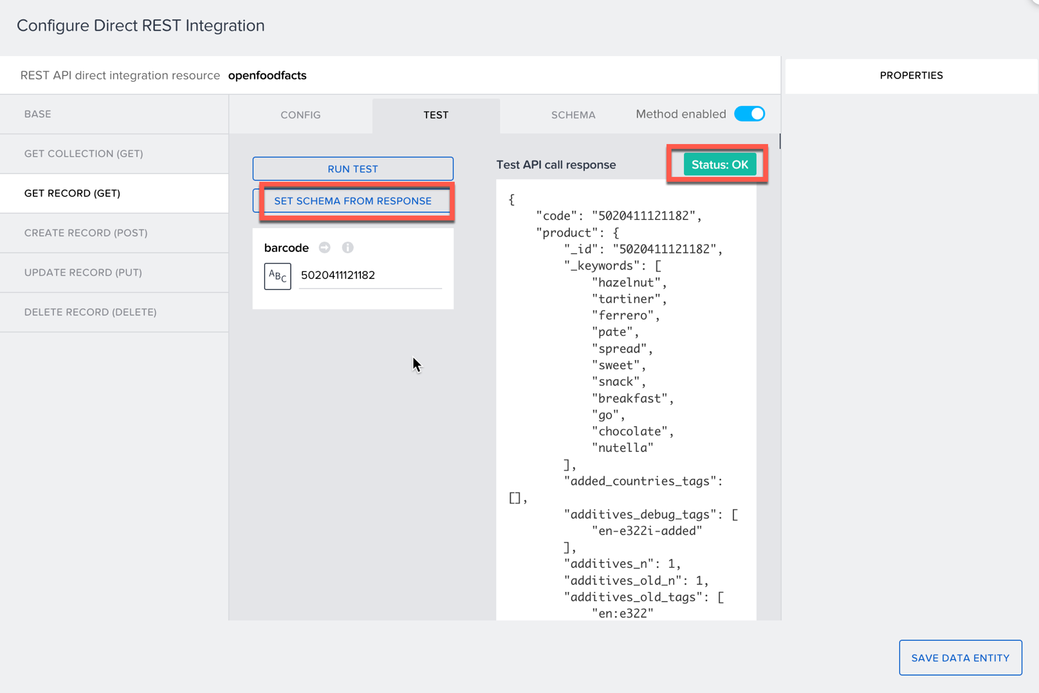  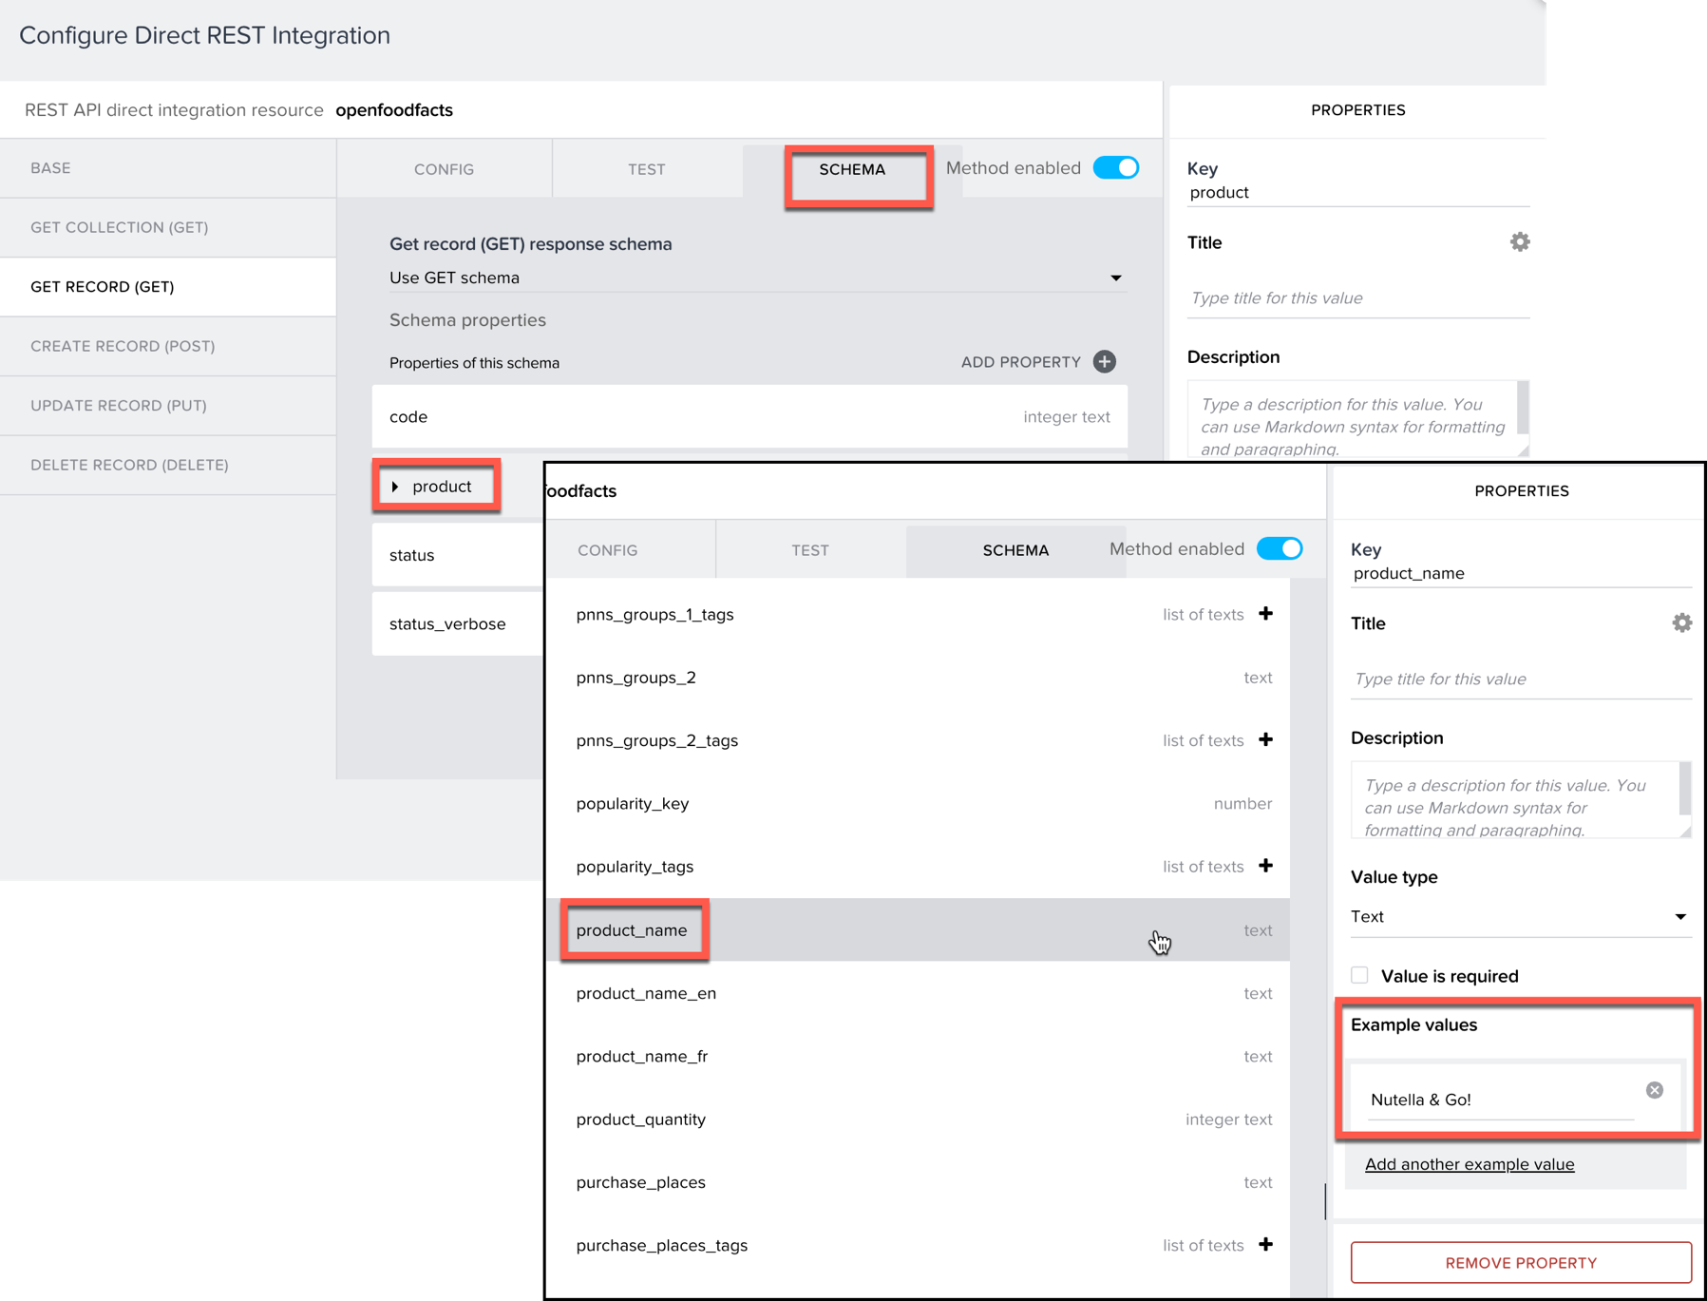
fetching and saving data
go back to "UI canvas" tab, choose scan barcode button  in logic canvas, delete the alert node  add "Data | Get Record" node, link it to its last node | 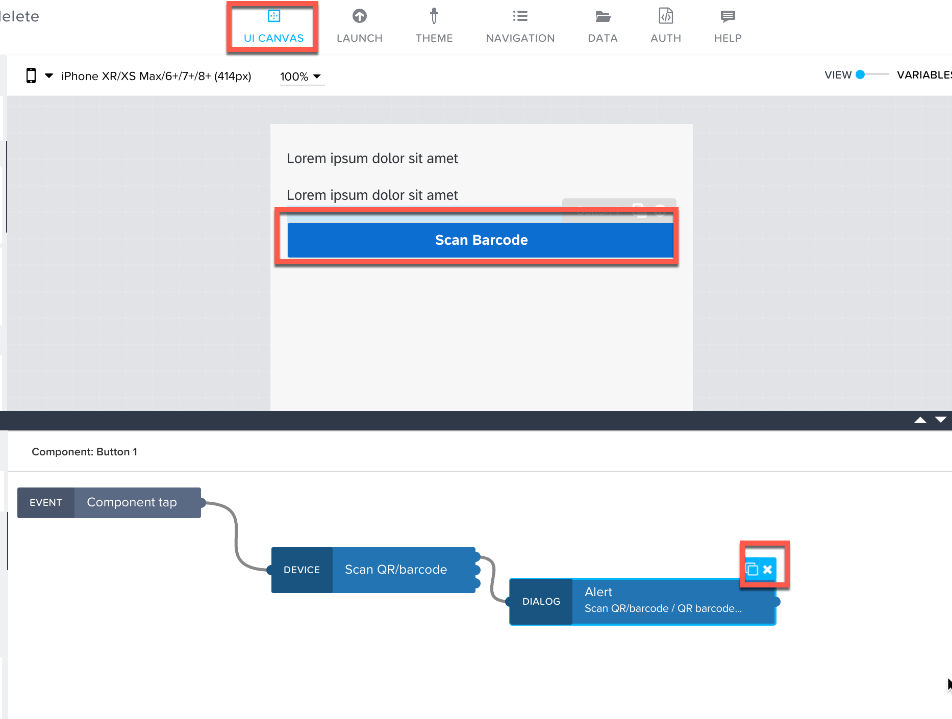
bind for get record > inputs > barcode | 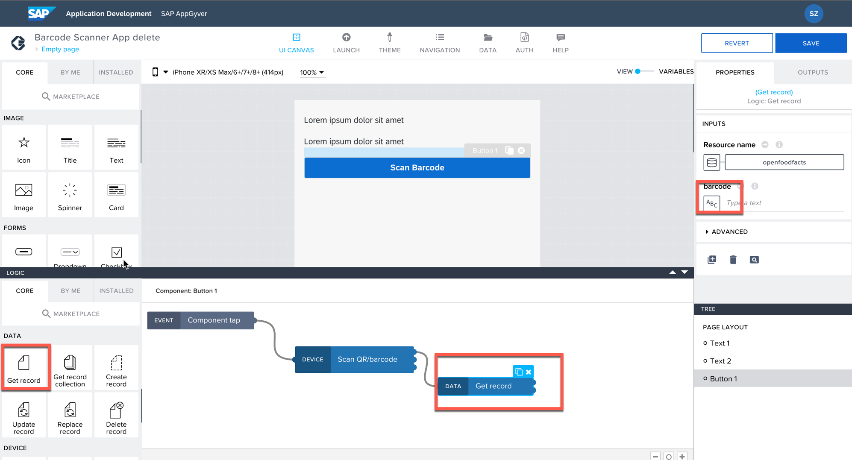
click output value of another node > scan qr/barcode | 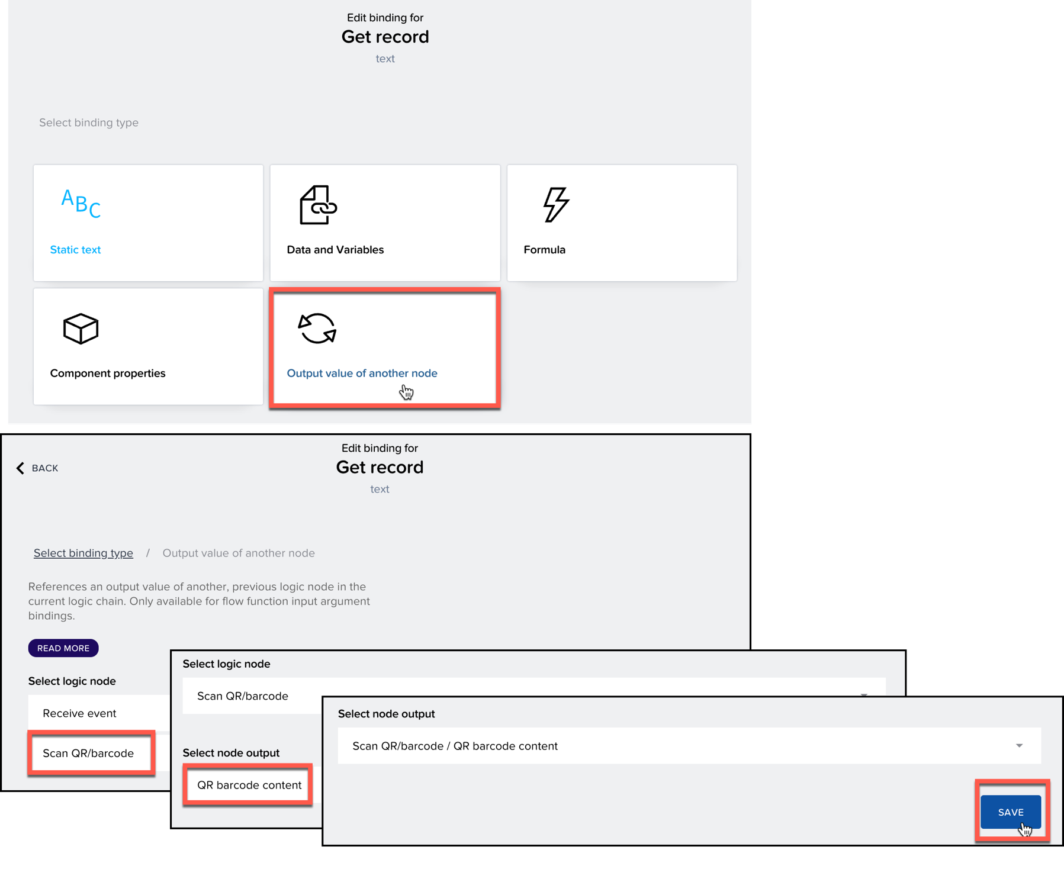
create a data variable:  in the panel of right-top, switch from view to variables,  choose add data variable  select add data, from data resource: openfoodfacts  name it FoodFact  change variable type to single data record | 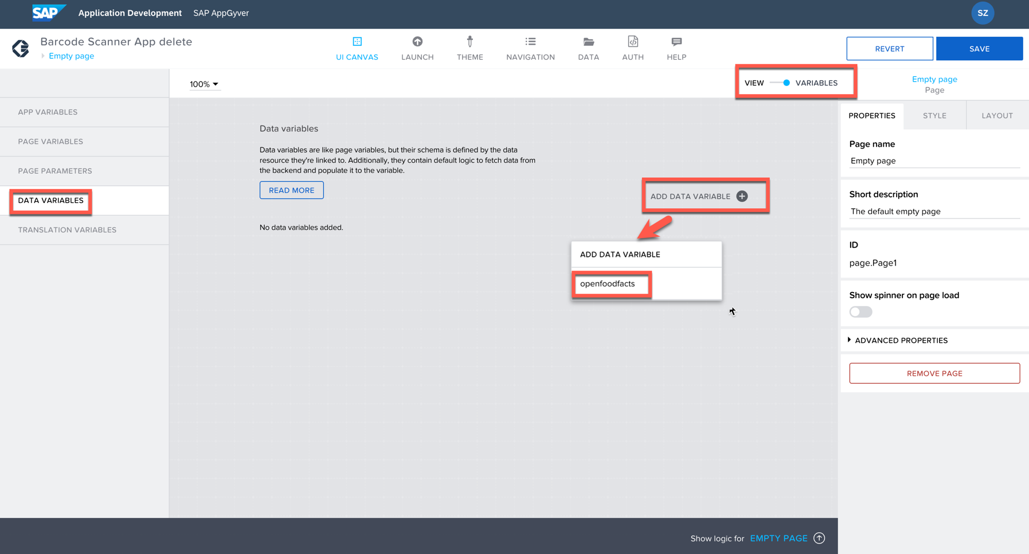  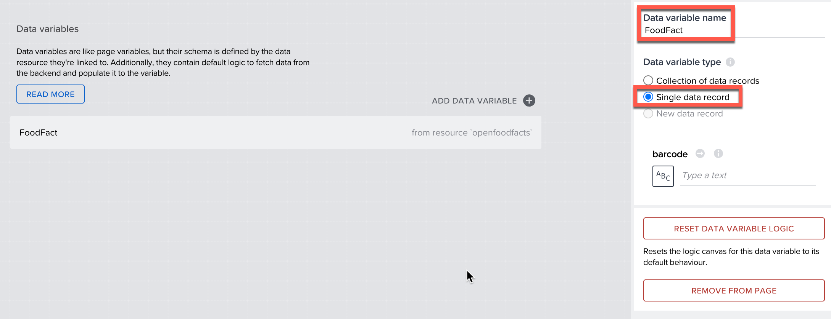
select FoodFact, in logic canvas, all nodes except the two page event nodes (because the default logic here is to fetch data every 5 s, and we only need to fetch data after button is tapped) | 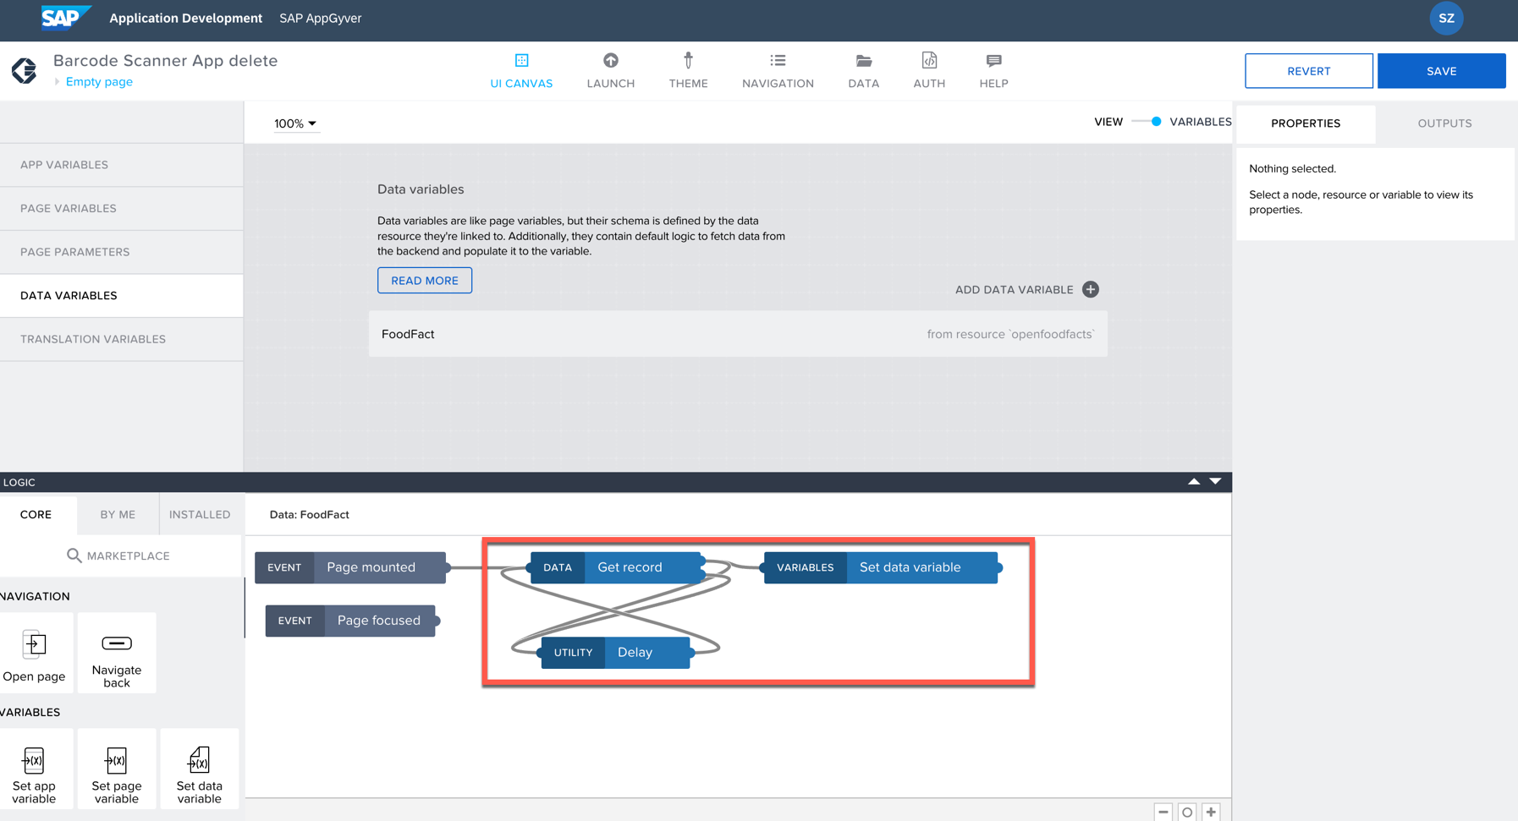
select scan barcode button, in its logic, add "variables | set data variable",  bind data for its input: output value of another node > Get record > Record  save | 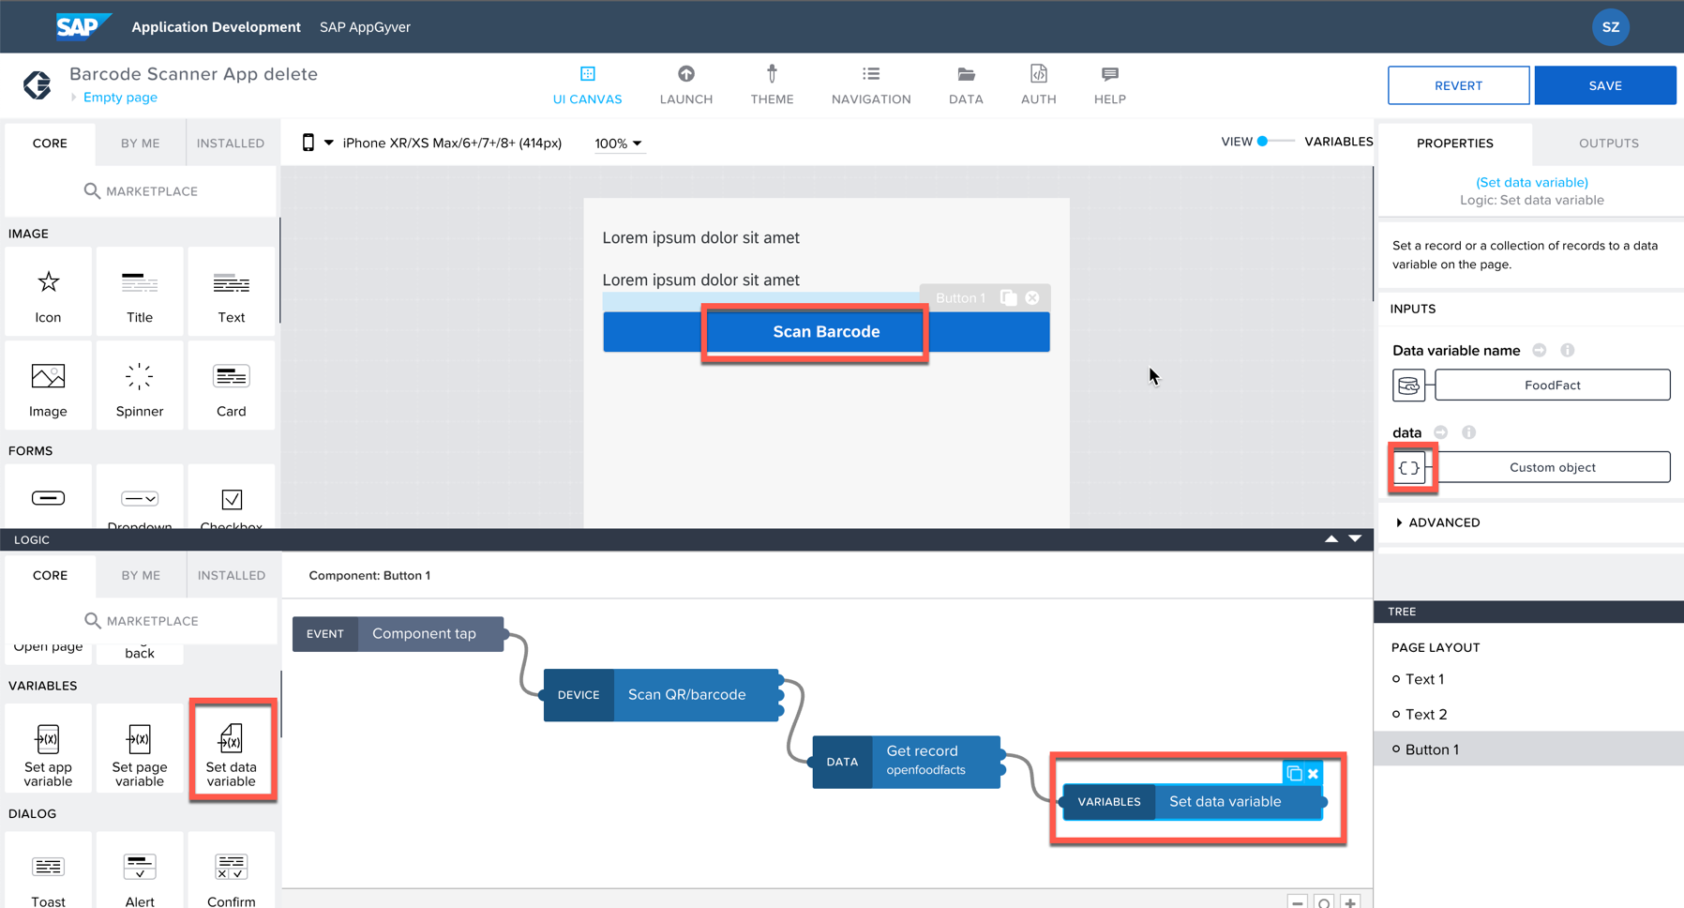  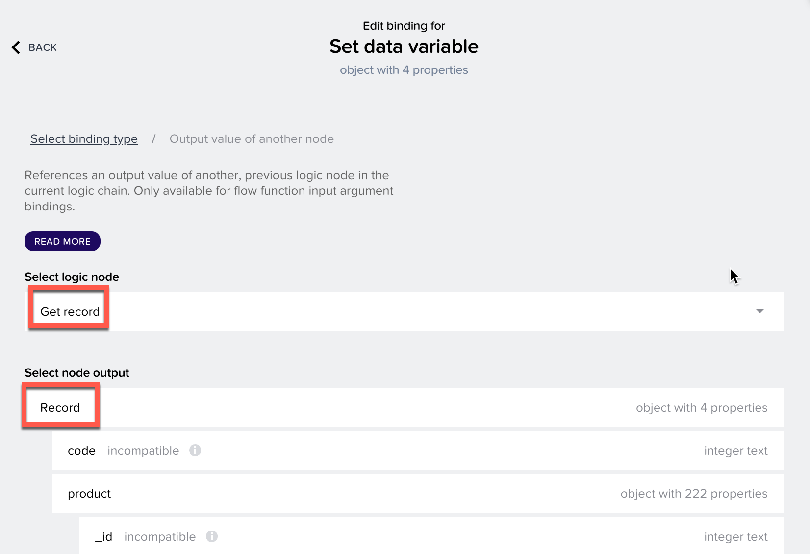
display the data in two texts
select first text,  edit binding for content > data and variable > data variable > FoodFact > FoodFact.product.product_name (you can ctrl+f search for the field "product_name" instead of scroll down the list) > set preview value "food product name" > save | 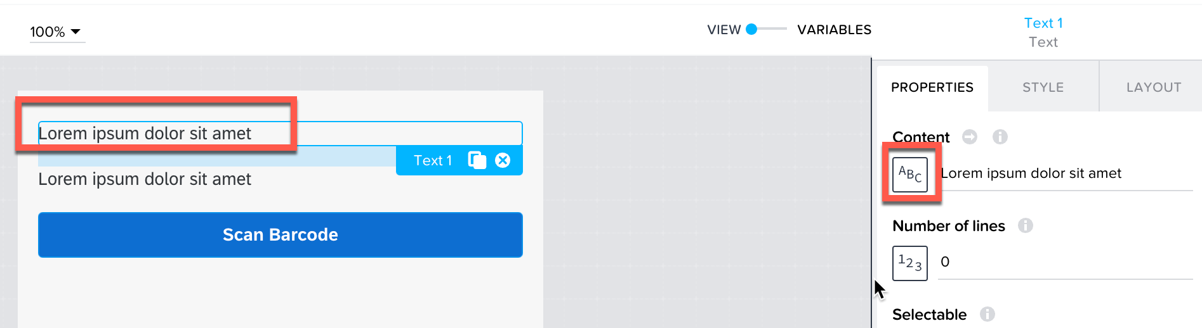  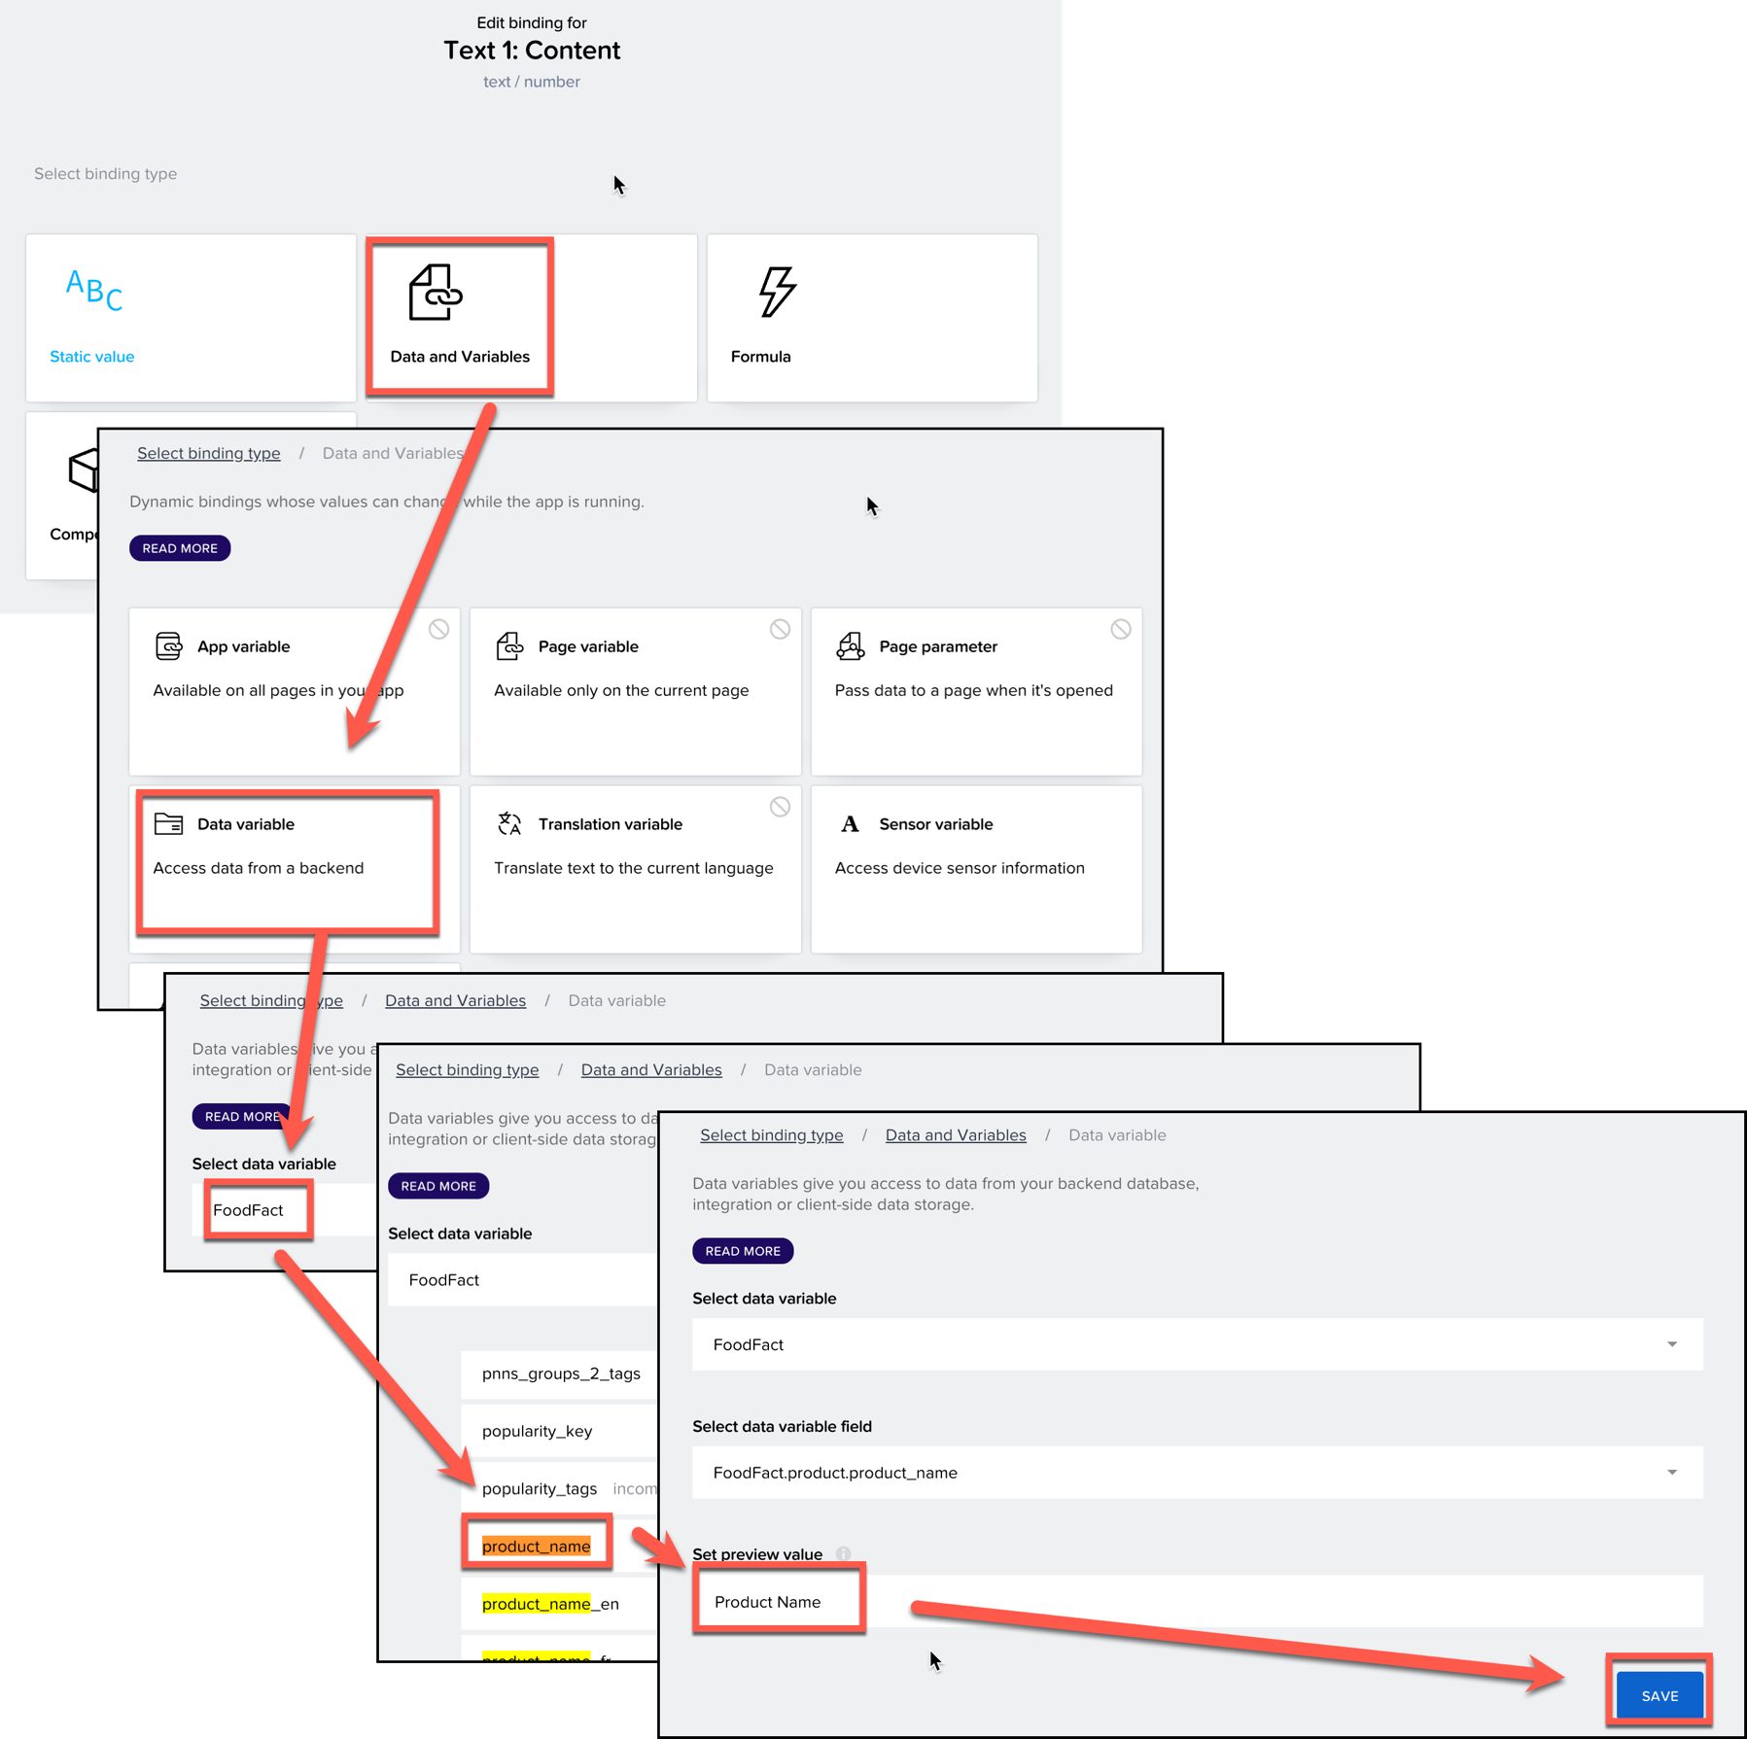
do the same for second text,  bind to FoodFact.product. nutriments["energy-kcal_100g"] | 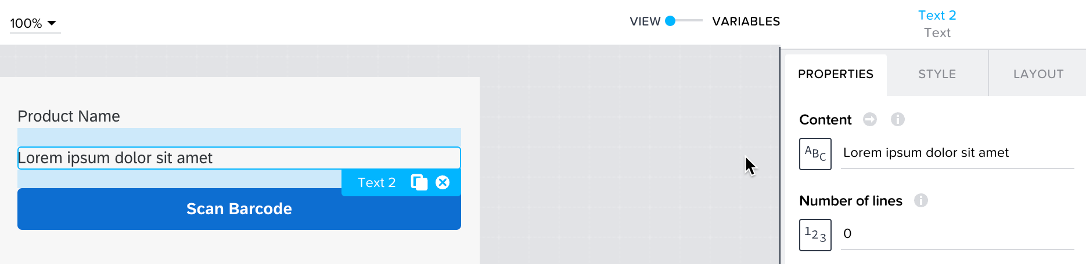  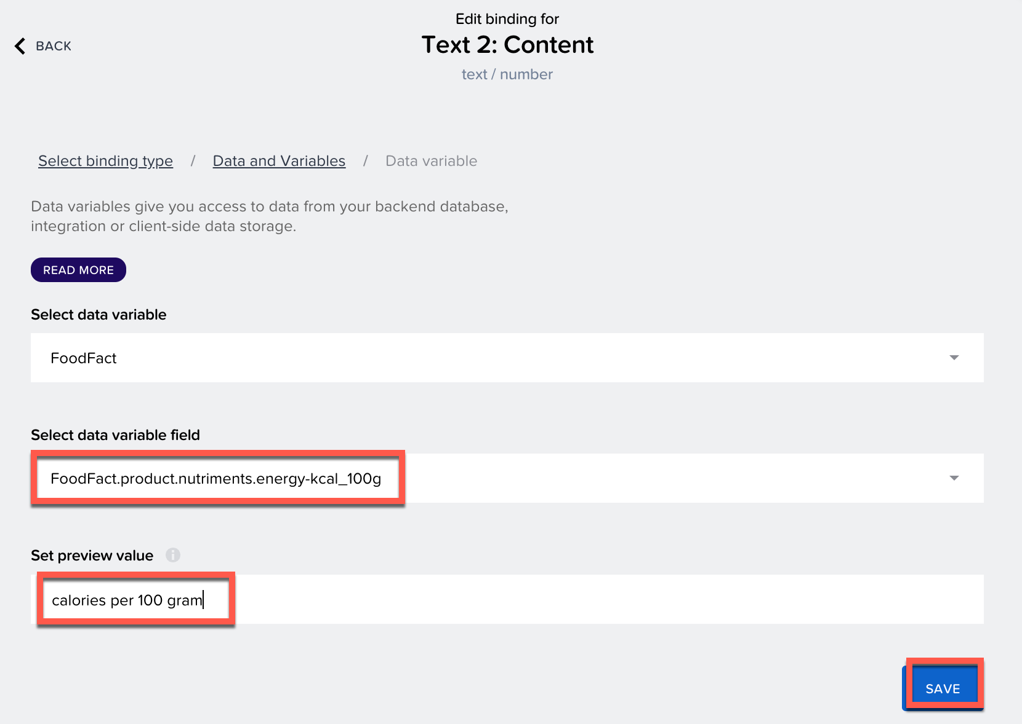
edit the string in formula:  "calories per 100g: " + data. FoodFact.product. nutriments["energy-kcal_100g"]  check the string to be displayed in preview  save | 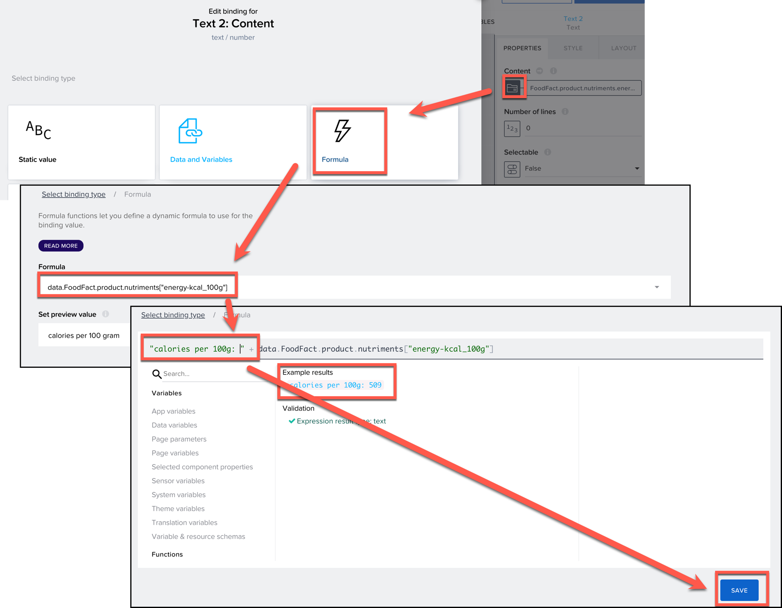
you can save the project and check in Preview app on your mobile device:

then you will find the default text is not user friendly (if the data has not been retrieved, the display should be hidden)
select first text > properties > advanced properties > edit the binding,  binding type > formula >  formula data.FoodFact.status == 1  save  test on your device | 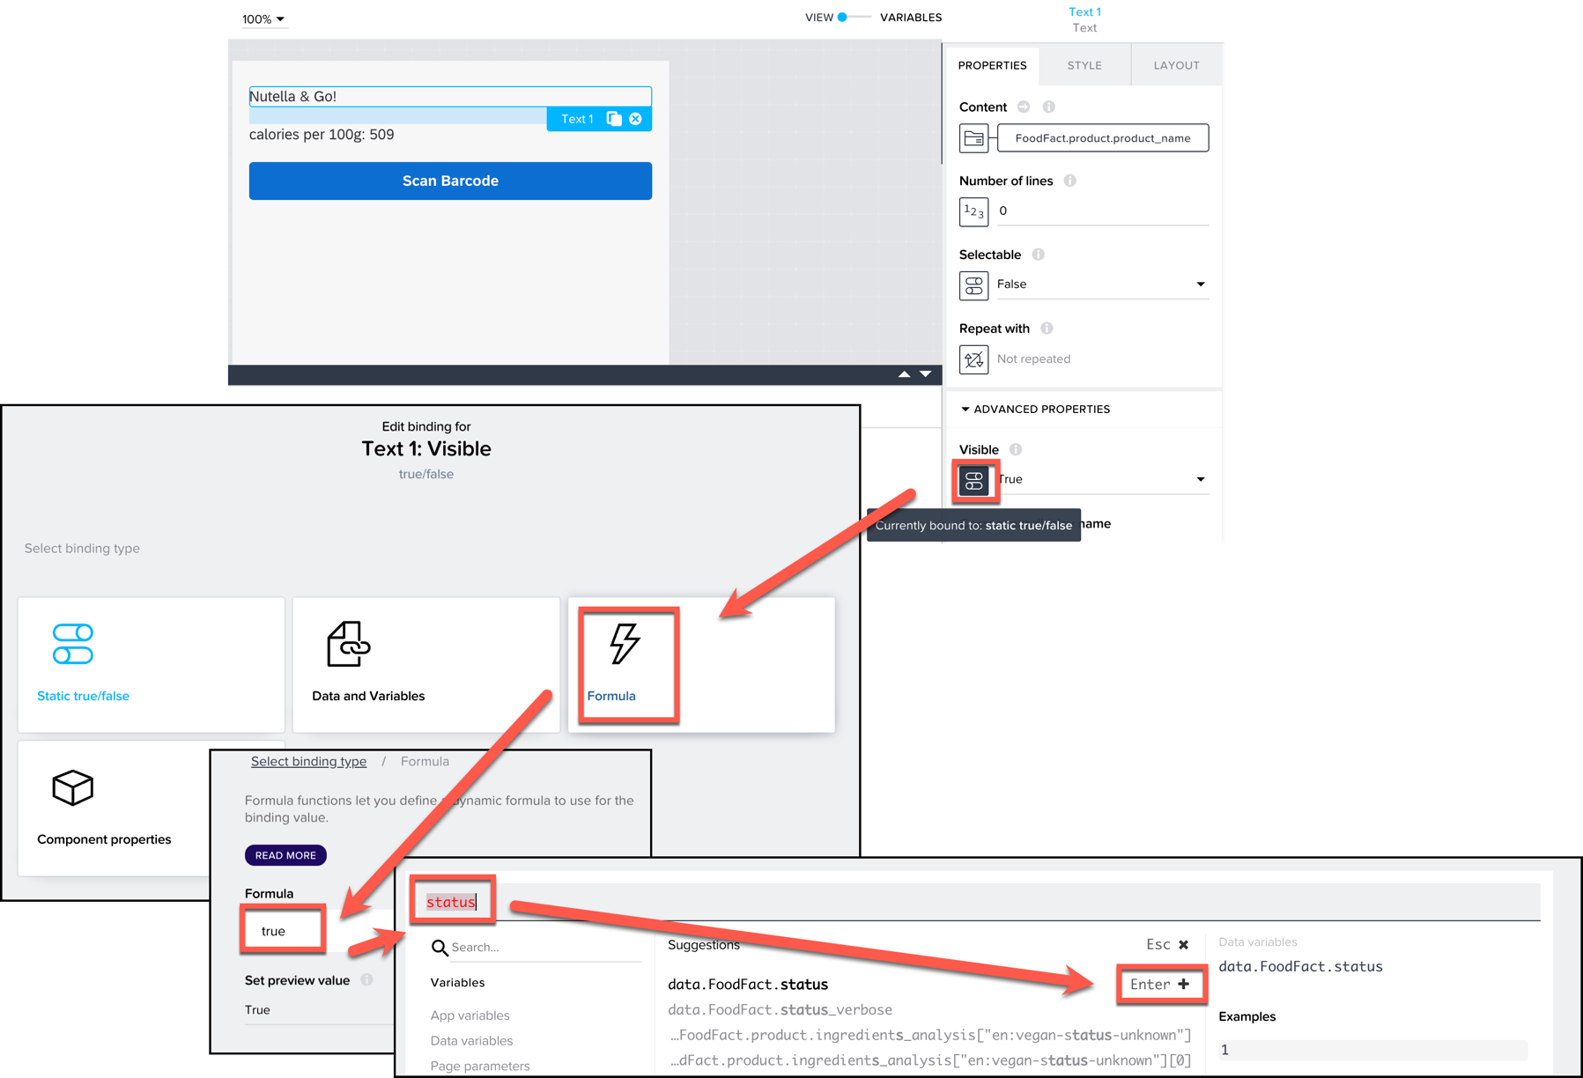

SAP Sales Cloud Extension - Appointment List App
Descriptin | Screenshot
UI
create a project : Appointment List  Page name: Appointment List App  change the Headline component to: Appointments  delete text component | 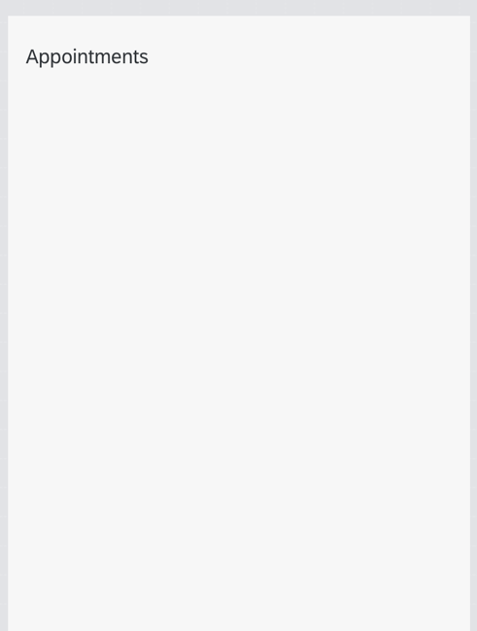
add Card component, | 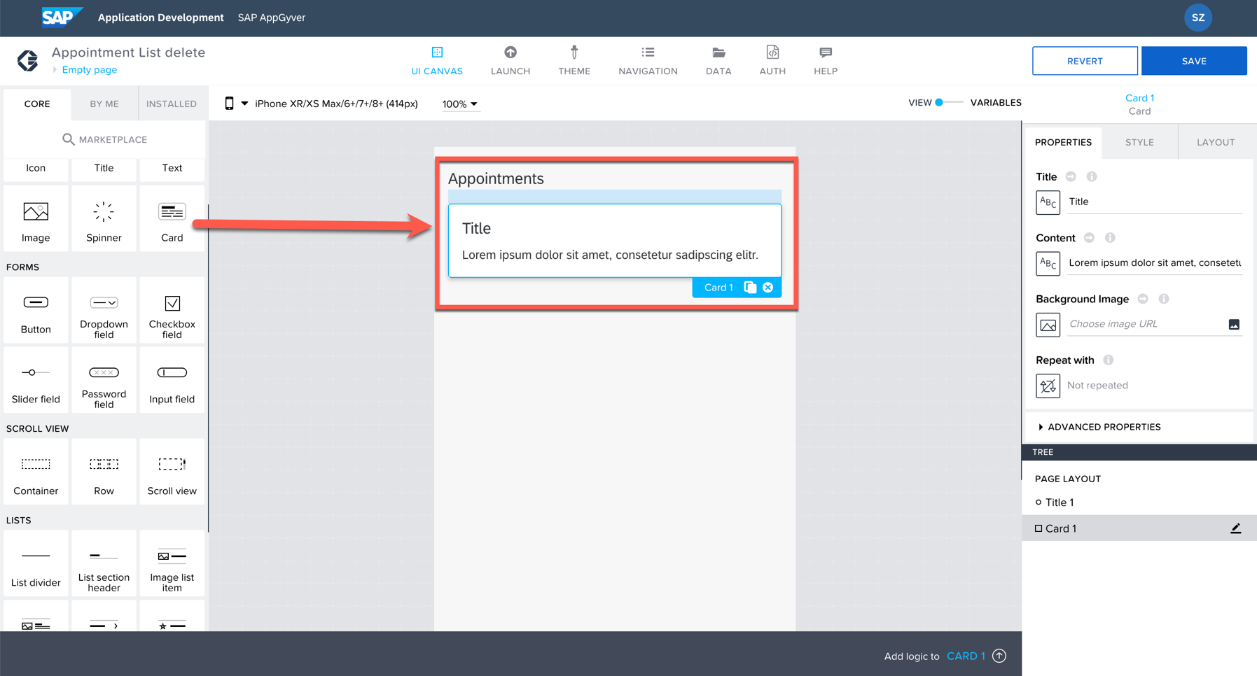
open its component template editor  add text component to the card  close the component template editor by double-click outside of the card component (or exist on top-right)  save | 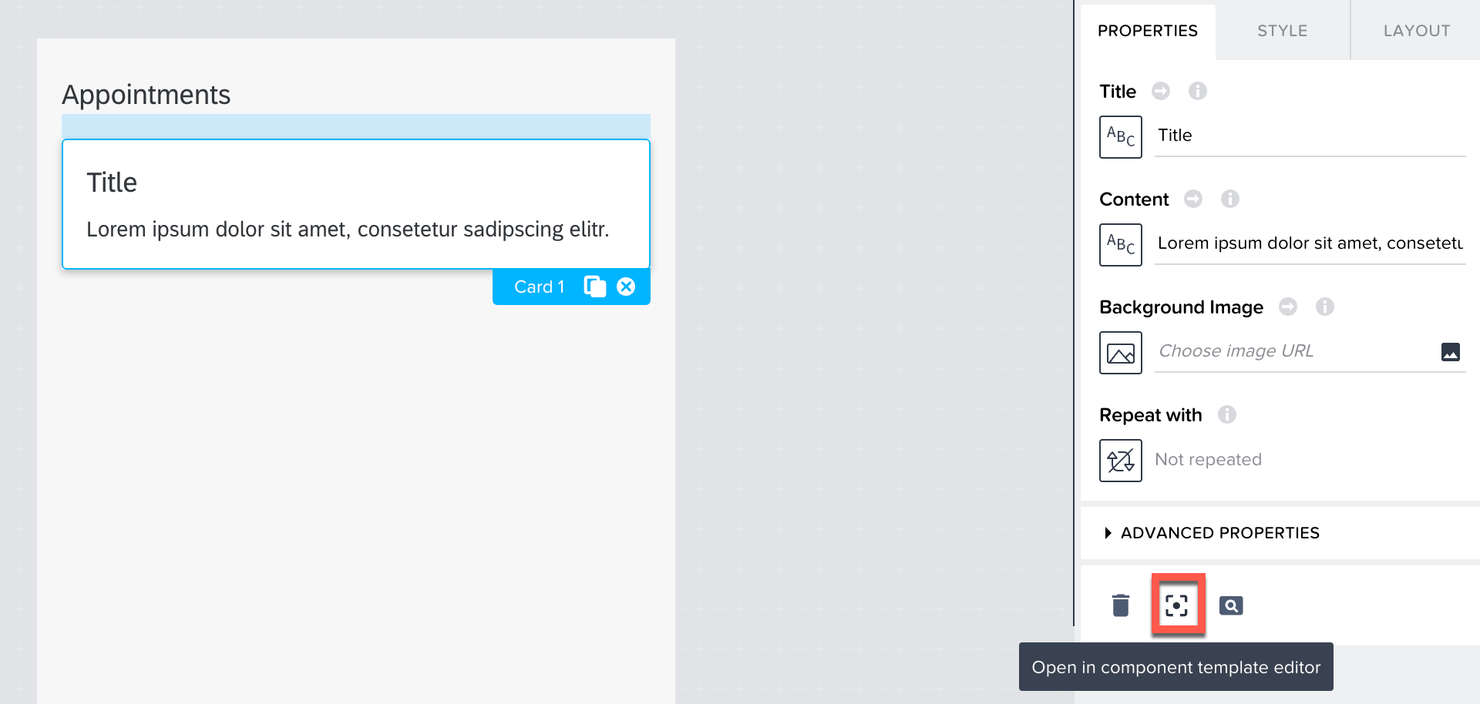  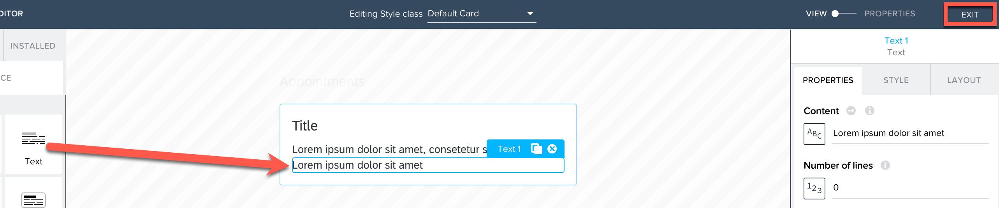
connect to SAP Sales Cloud OData API
verify the API URL by open it in browser:  https://btp150-proxy.c-2828549.kyma.ondemand.com/sap/c4c/odata/v1/c4codataapi/$metadata | 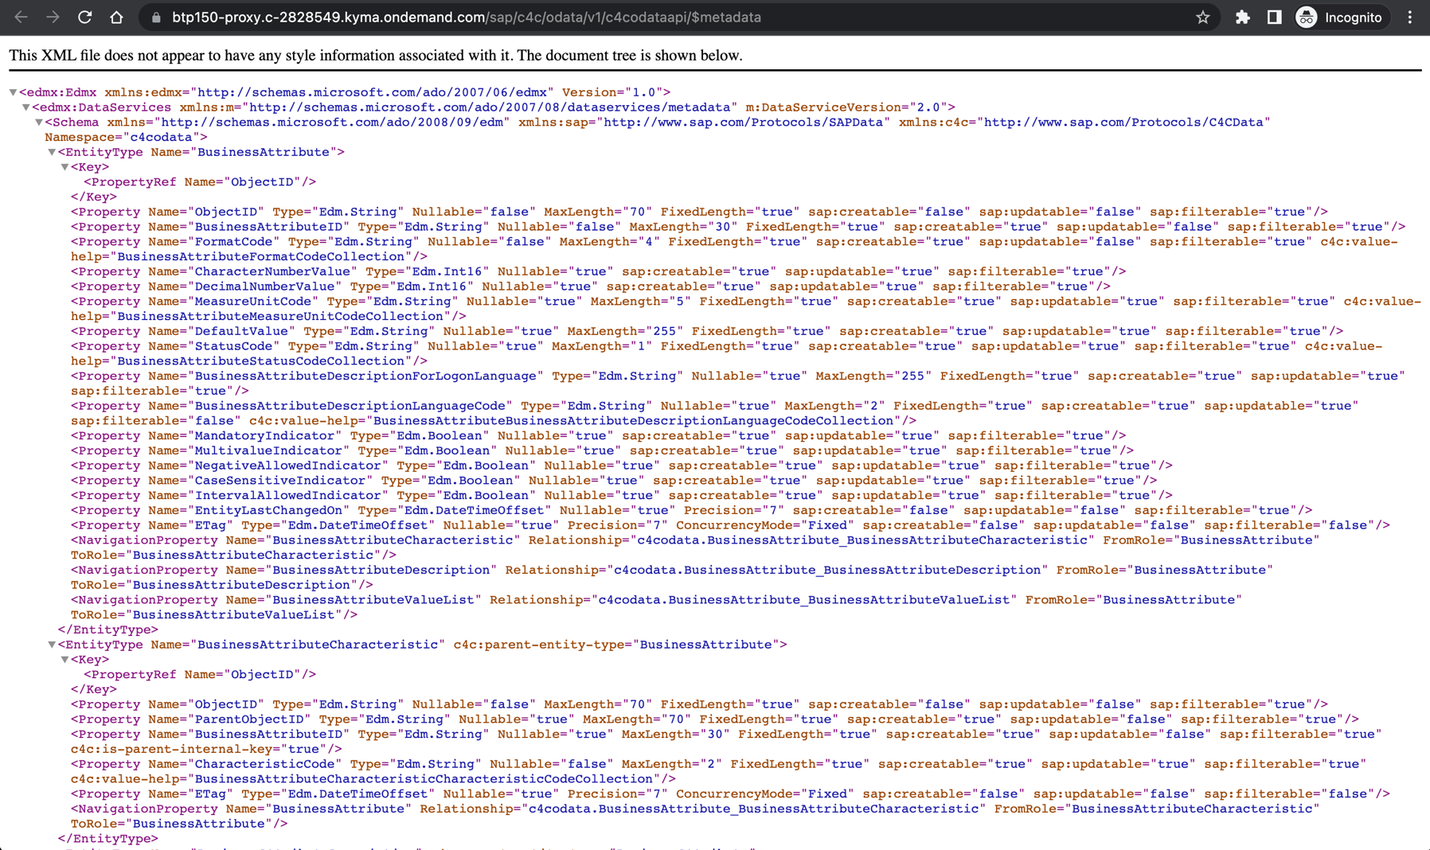
in Data tab > add data resource > OData integration > | 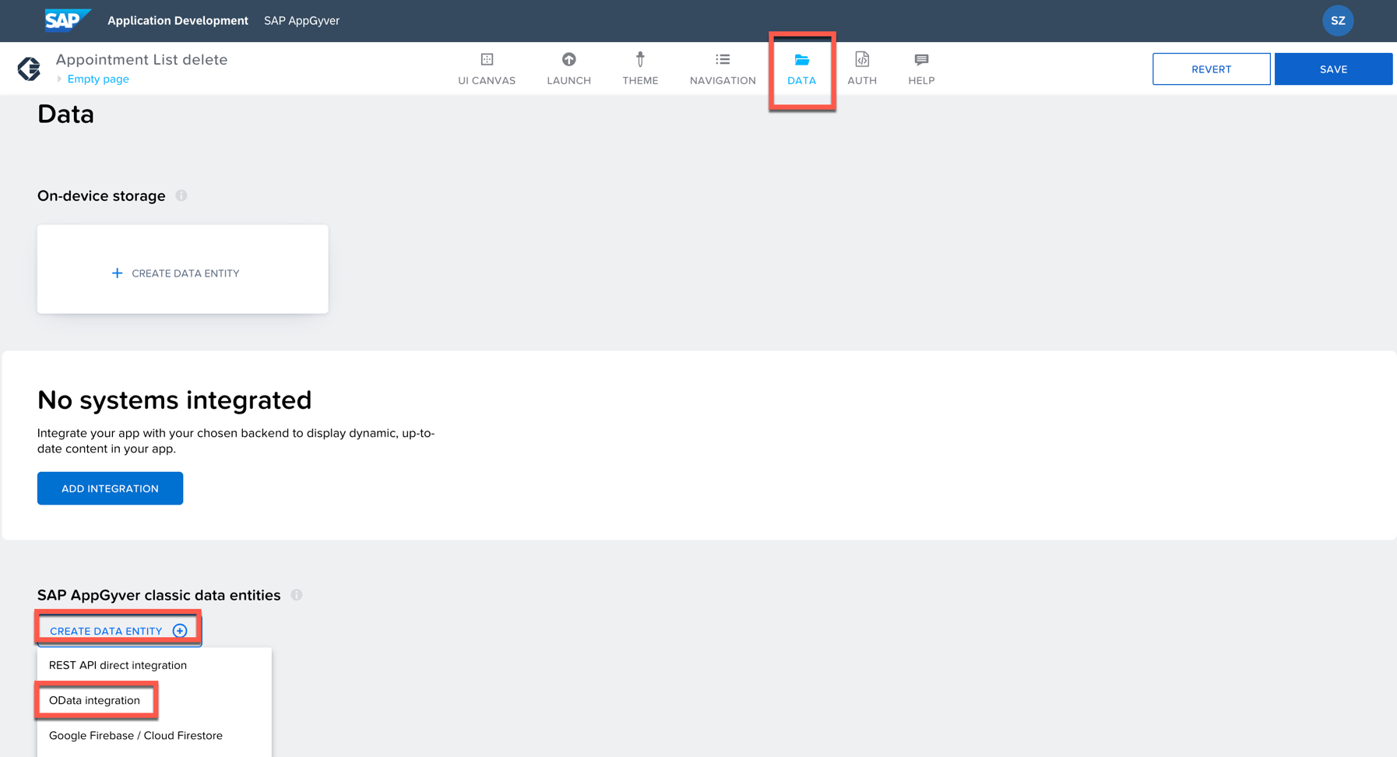
choose basic authentication (or no authentication).  copy and paste the url > select AppointmentCollection > switch on all > save data resource  https://btp150-proxy.c-2828549.kyma.ondemand.com/sap/c4c/odata/v1/c4codataapi/$metadata | 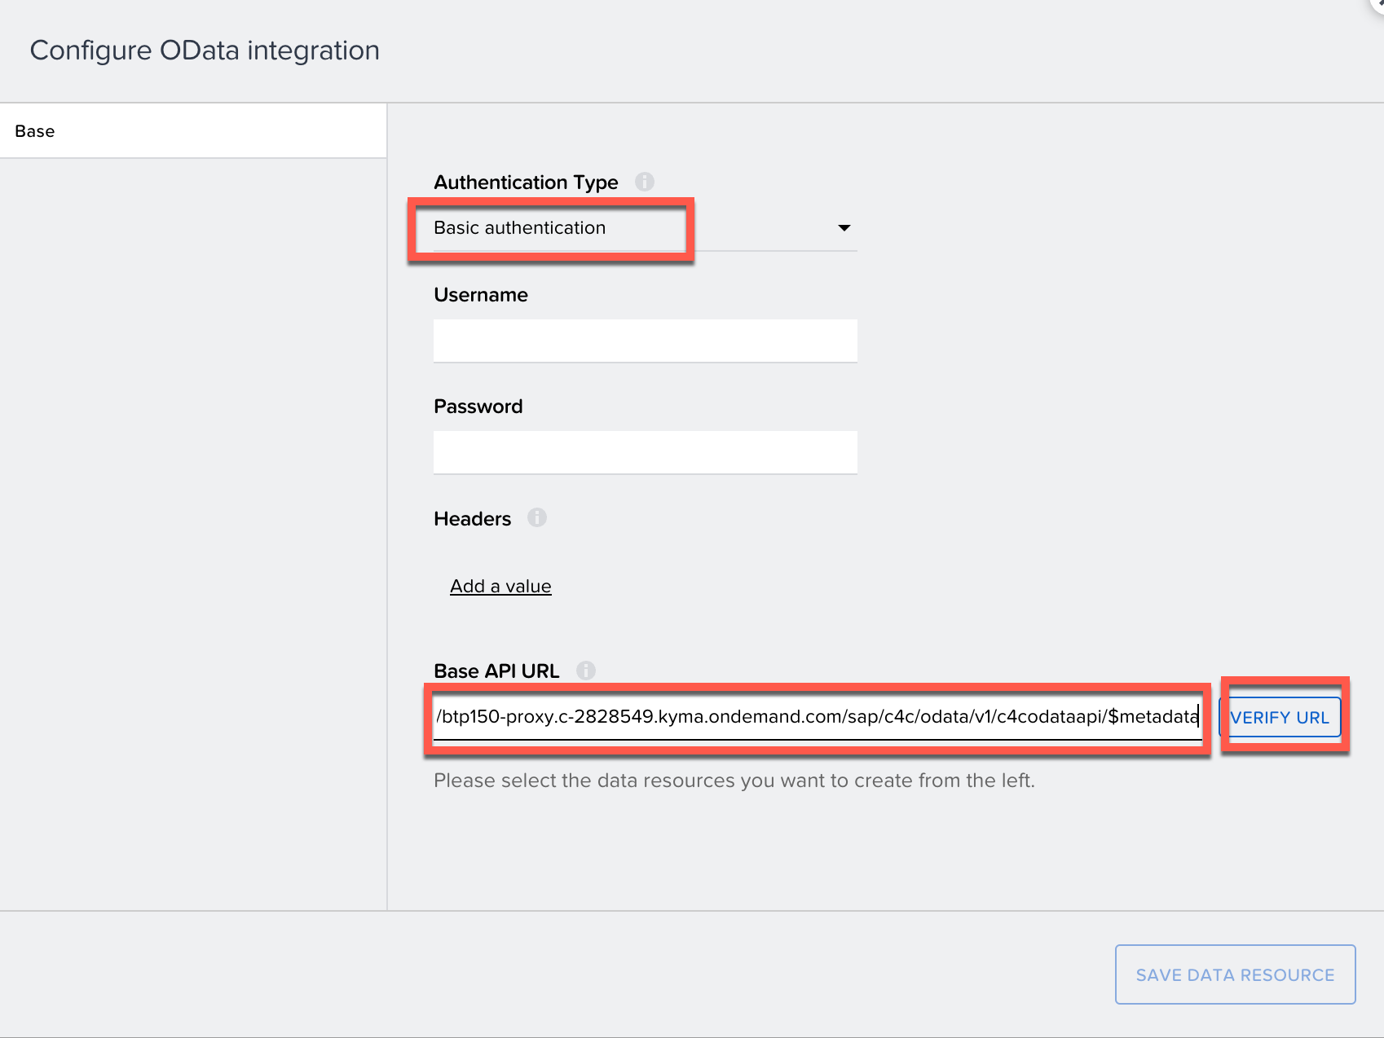  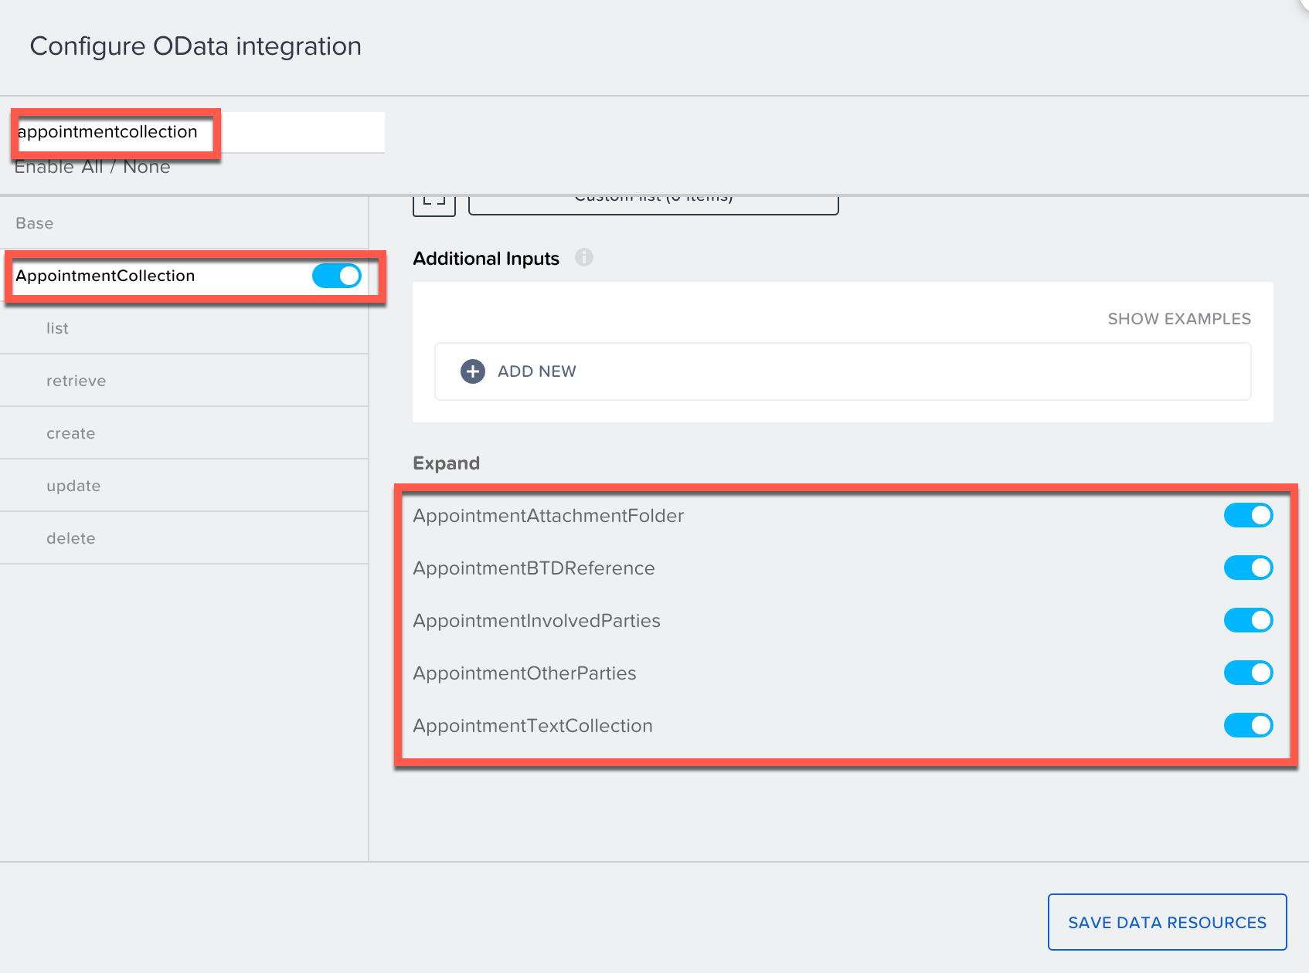
list > test > run test  the returned data is in JSON format {[,]},  find in text:  - subject  - categorytext  - organizerName  - appointmenttextcollection[0.text] | 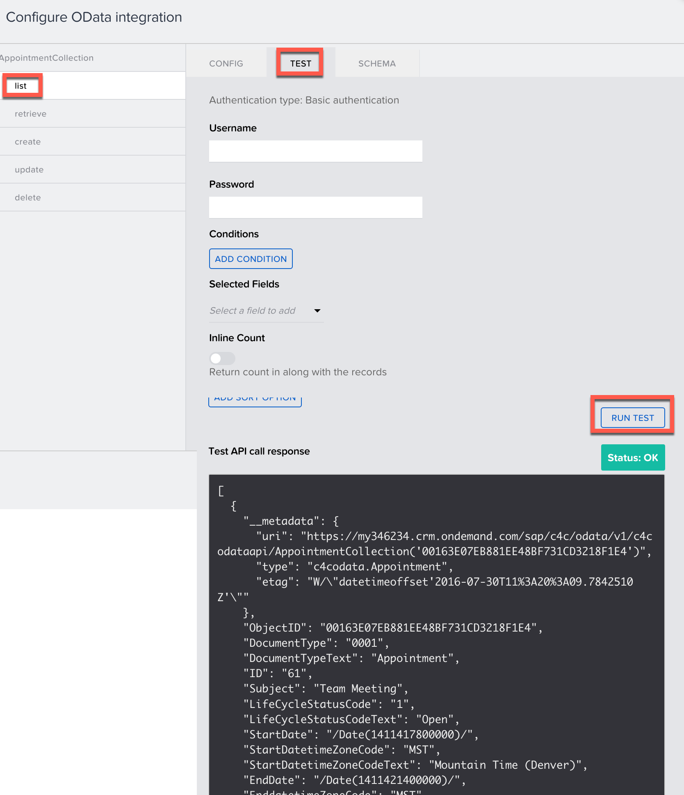
see schema  save data resource | 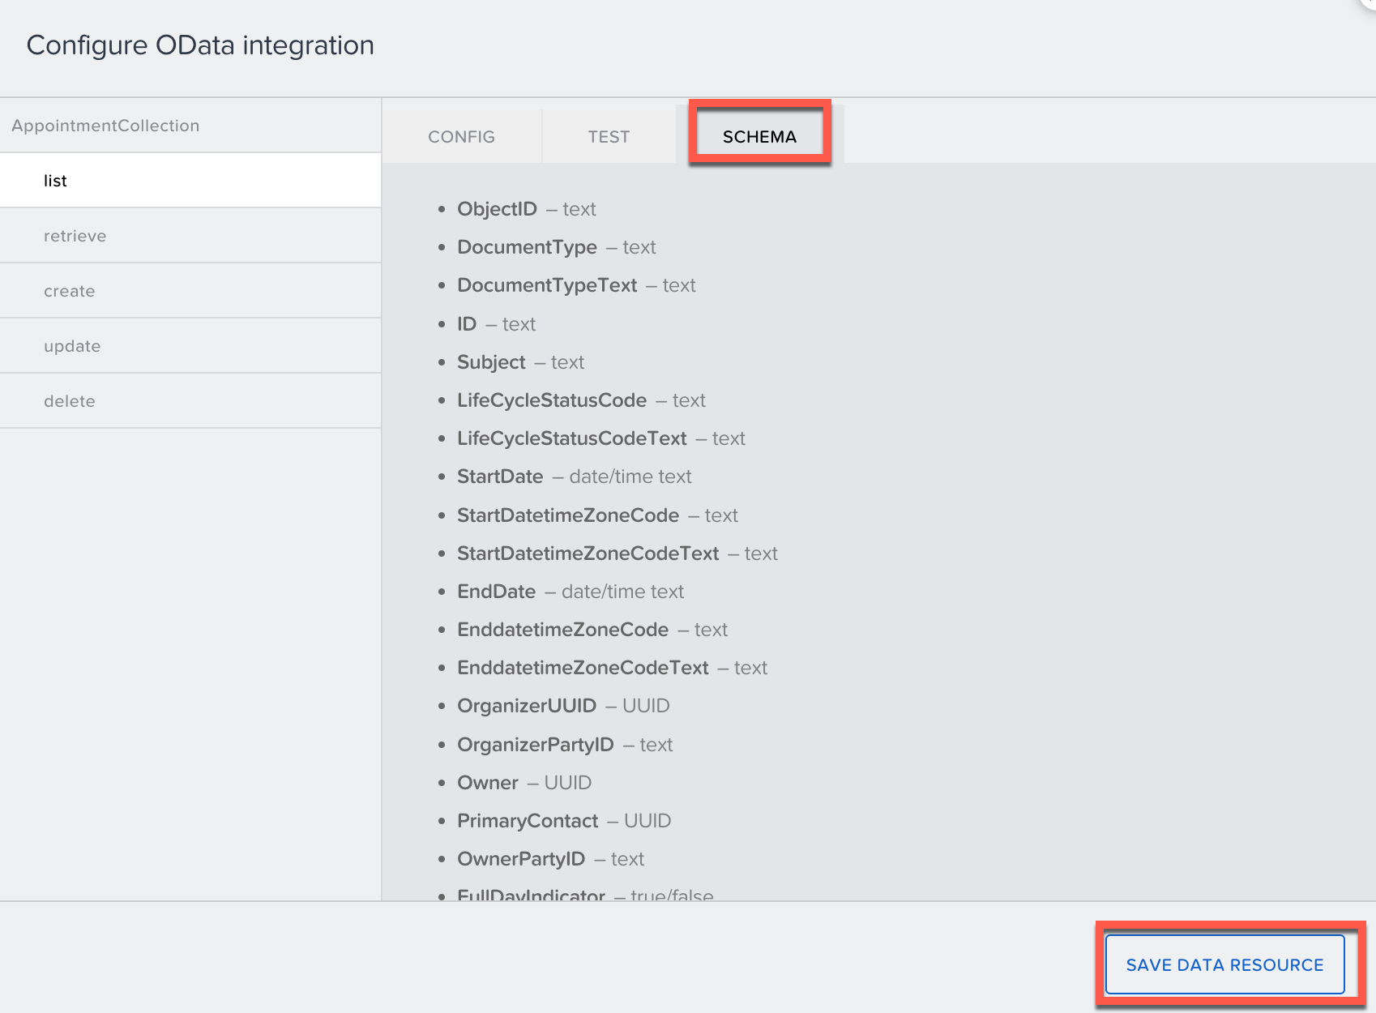
consume the data
get back to UI Canvas, toggle on Variables, create a data variable from the newly-added data source.  data variable type: collection of data records | 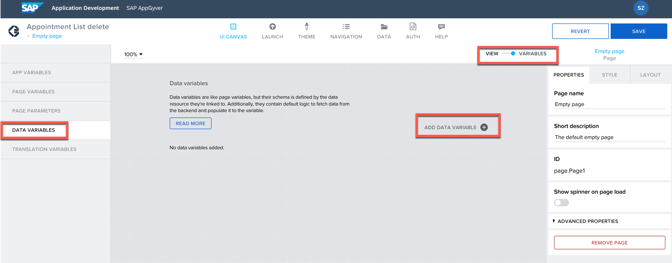
(optional) add basic authentication:  object with properties > auth type / username / password  authentication type basic  username Demouser  password Welcome1  no authentication, no username and password also works | 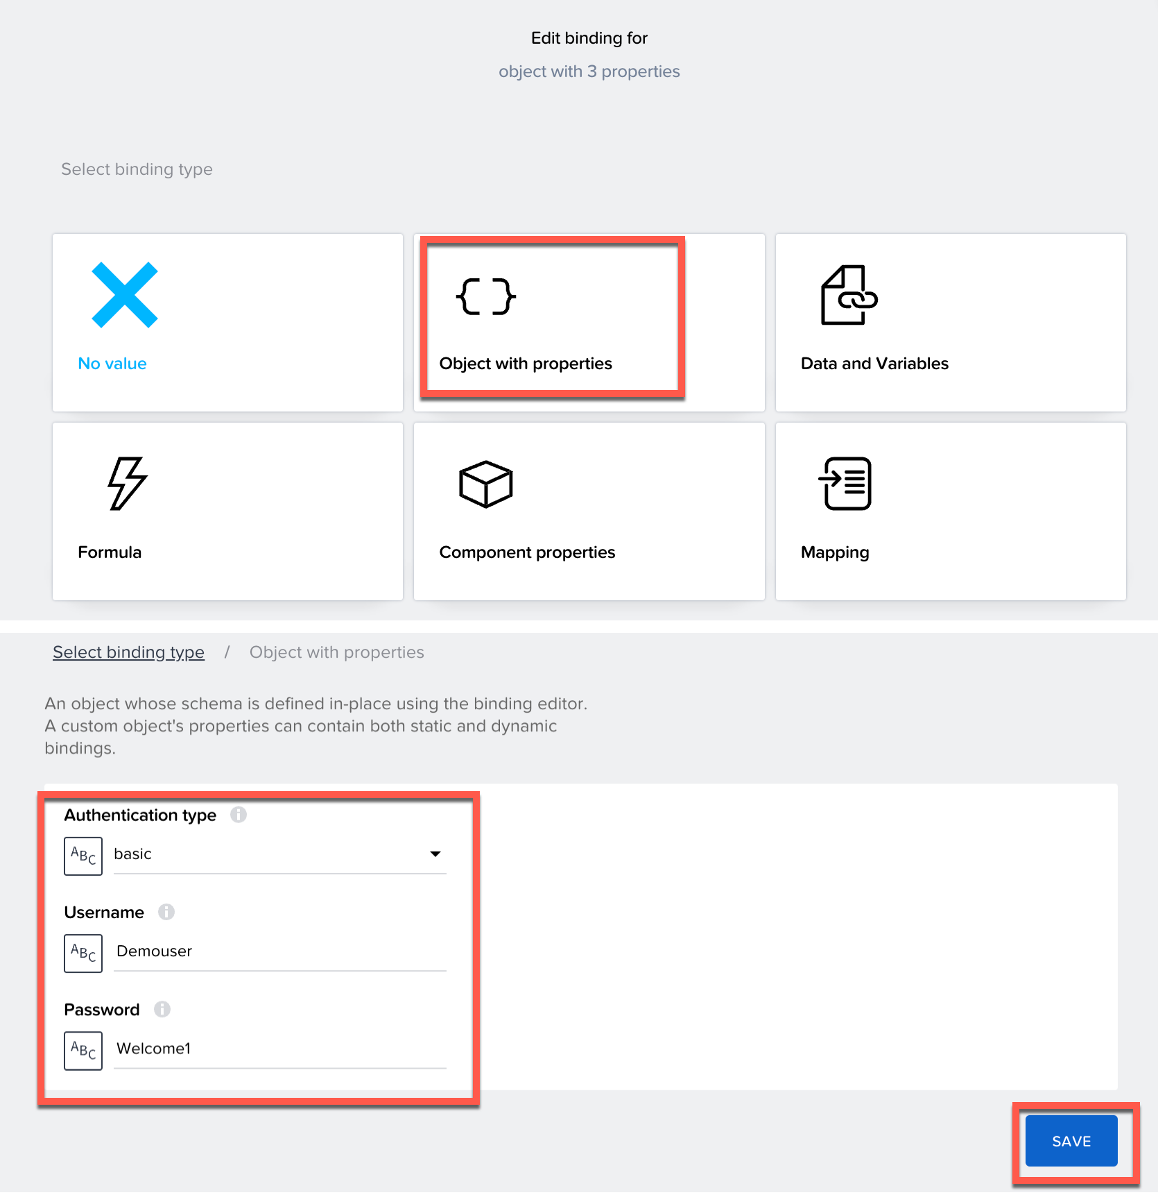
filter to show only the category of marketing:  filter condition > object with property > add condition (property and condition type are selected from drop-down list)  property condition type comparaed value  CategoryText equal Marketing  (note: the language of your phone should better be set to English! because the CategoryText will be displayed in your language, in my case, iphone,chinese=>"市场营销" )  save | 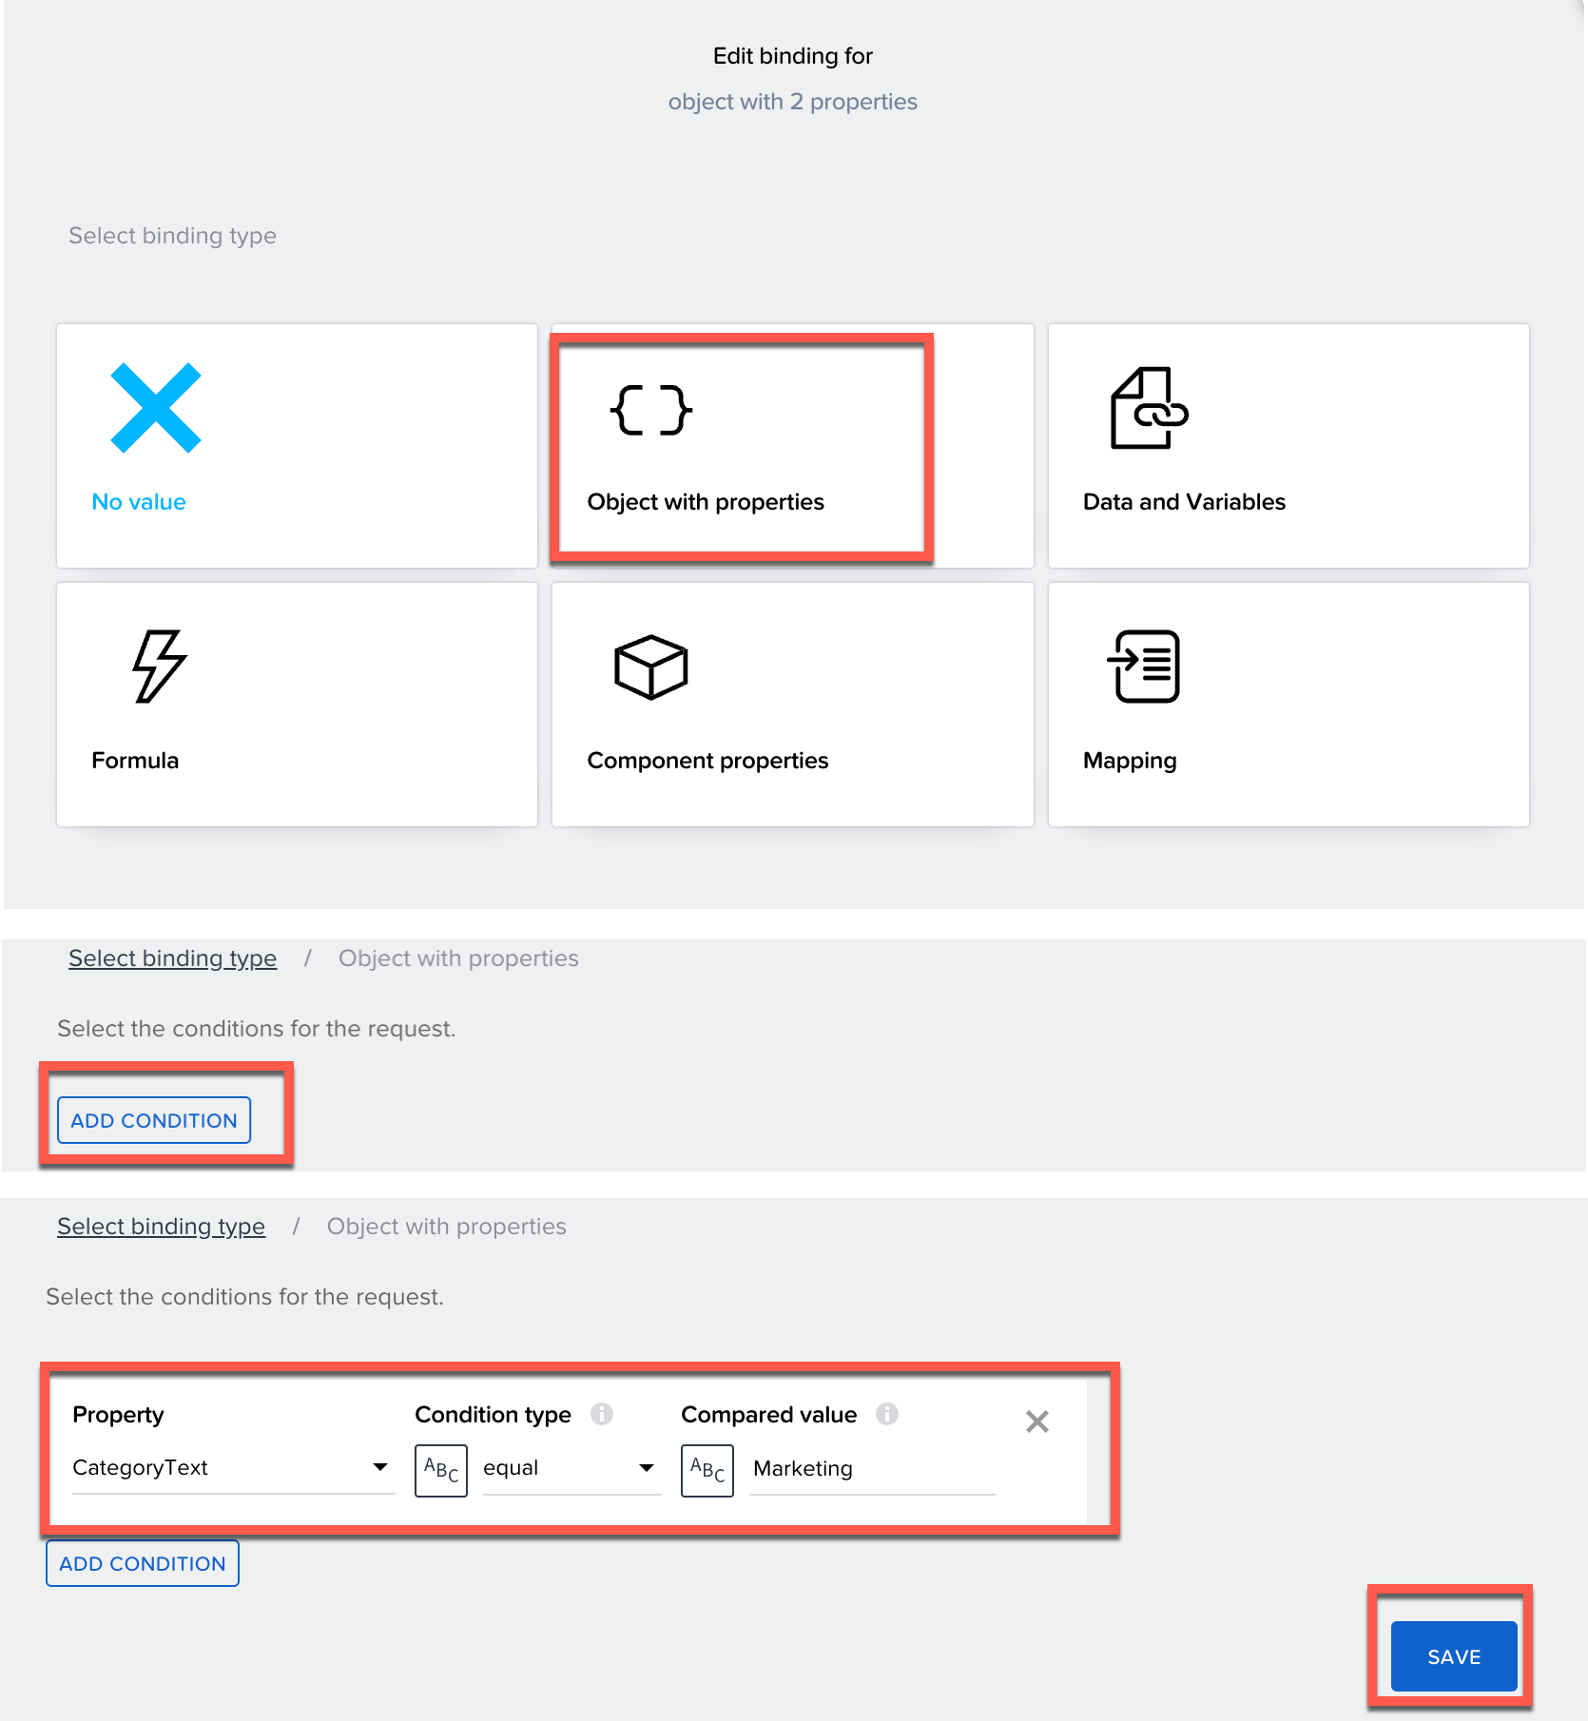
repeat the card component for the appointment list, and text component for the note list
choose card component > repeat with > data and variables > data variable > select AppointmentCollection1 > save | 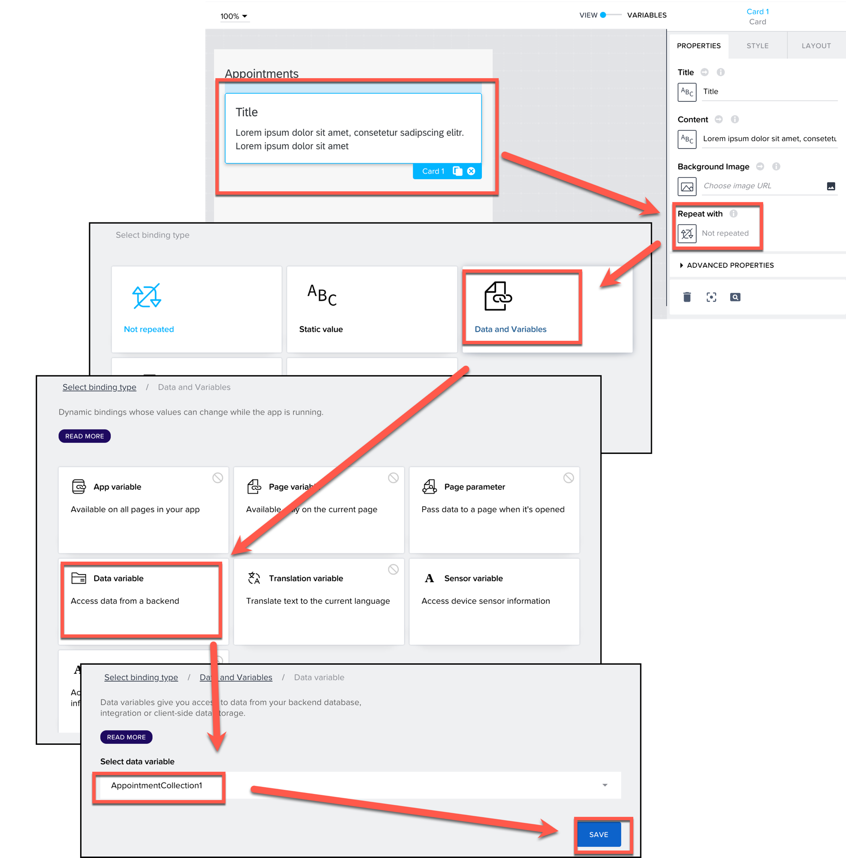
bind data to the card  bind title > data item in repeat >  select repeat current  repeat data property current.Subject  preview value Meeting With Customer A  * preview values are optional  save | 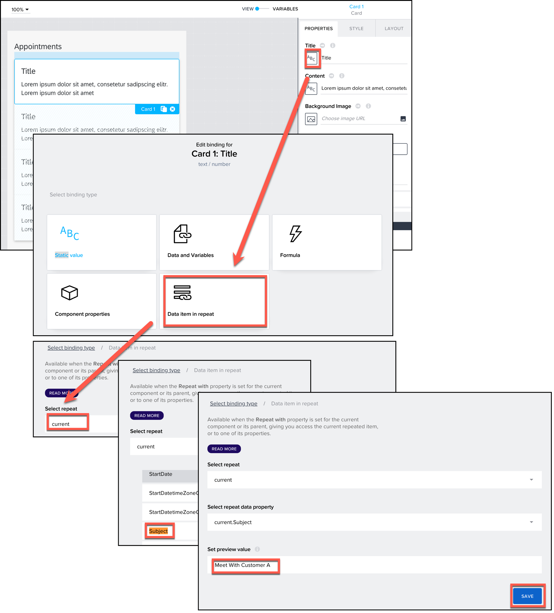
bind content > data item in repeat >  select repeat current  repeat data property current.OrganizerName  preview value Amy Lee  save | 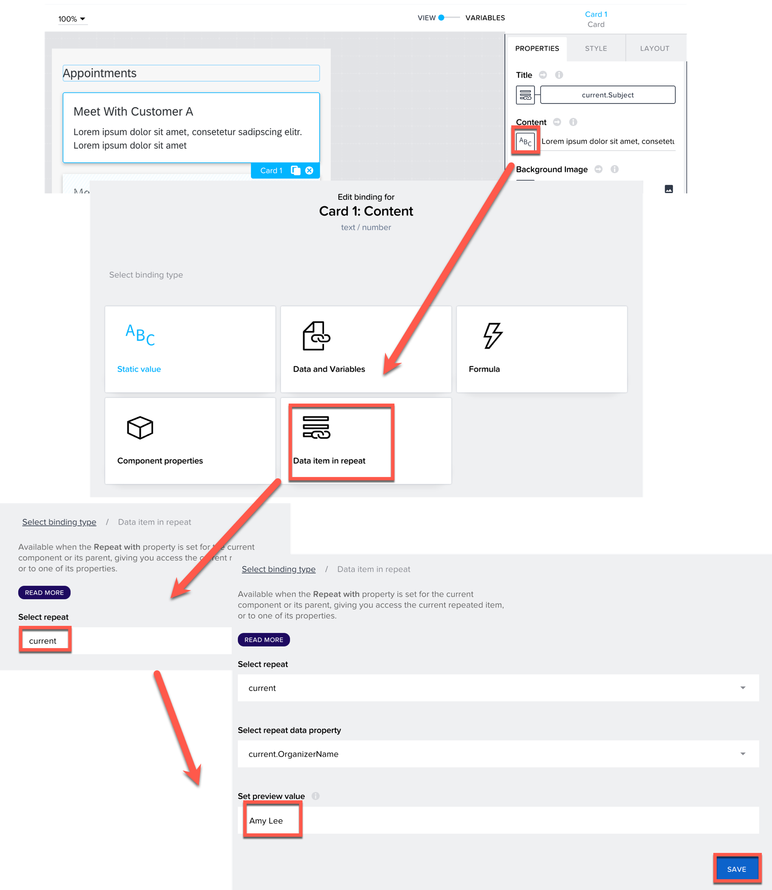
bind meeting notes (also repeated items) to card:  click the card template editor icon > select the text component > repeat with > data item in repeat >  select repeat current  repeat data property current.AppointmentTextCollection | 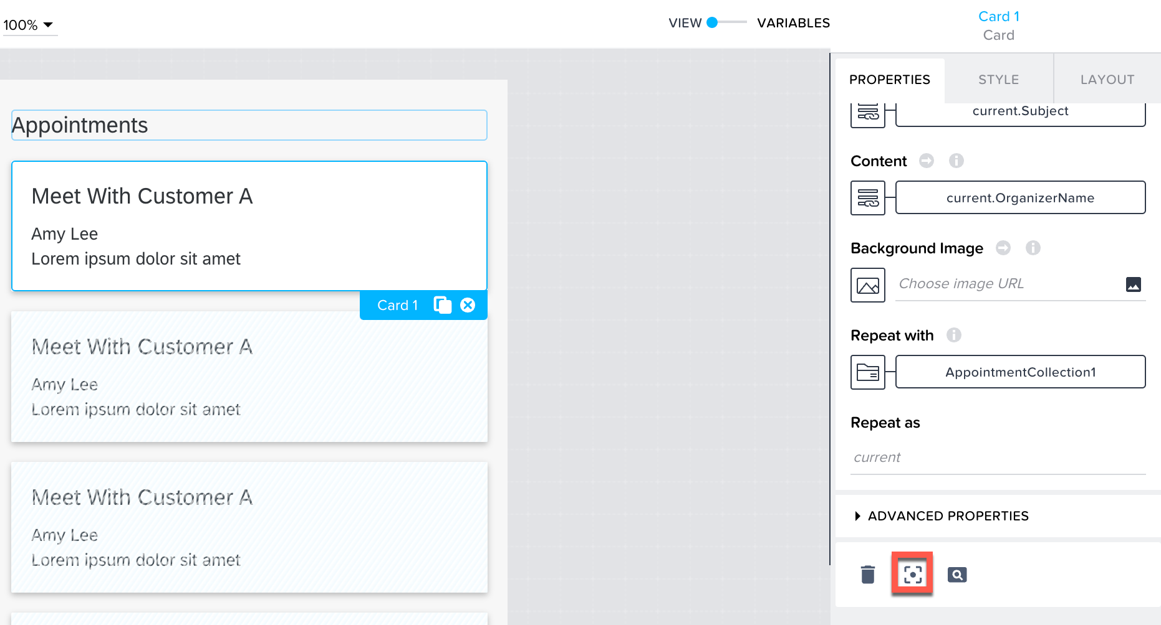  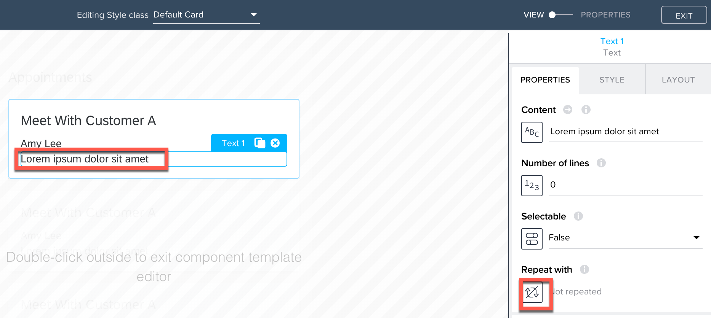  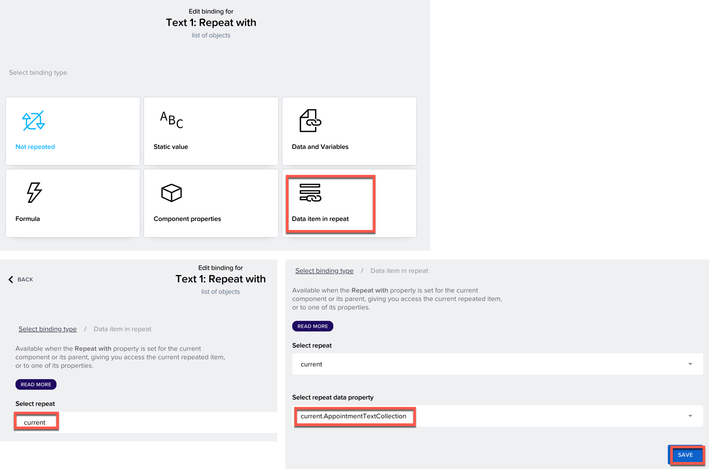
bind content > data item in repeat >  select repeat current  repeat data property current.Text  preview value prepare the slides beforehand  save | 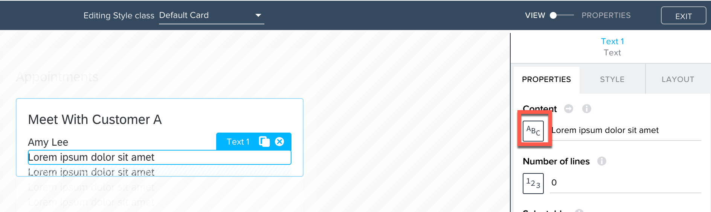  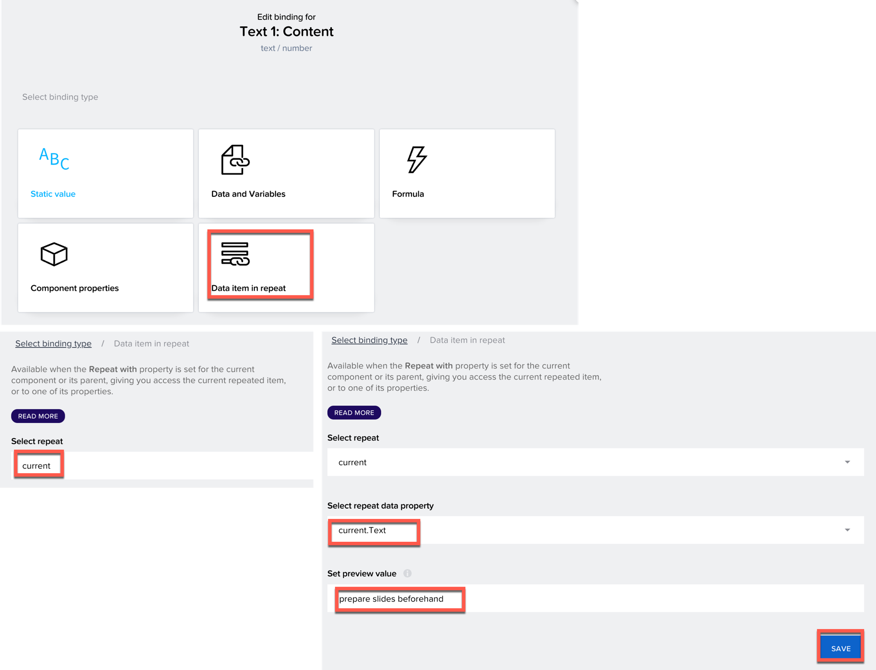
preview on the phone | 